Museum Without Walls

**You Look**

**Familiar**

**Curator: Ulya Soley**

2018

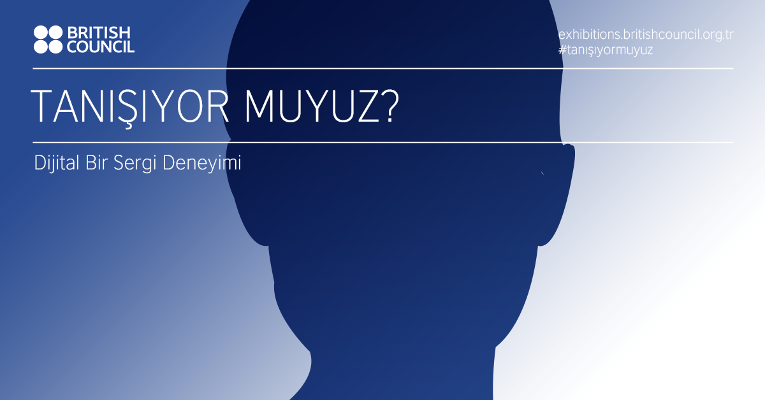

You Look Familiar explores the power of portraiture to challenge stereotypes through the portraits from the British Council Collection.

### Artists

Frank Auerbach, Craigie Aitchison, Jake and Dinos Chapman, John Davies, Tracey Emin, Lucian Freud, Michael Fullerton, Richard Hamilton, Lubaina Himid, Gary Hume, Morag Keil, Sarah Lucas, Kenny Macleod, Chris Ofili, David Shrigley, Mark Wallinger, Madame Yevonde.

### Curator

Ulya Soley

### Curatorial text

You Look Familiar explores the power of portraiture to challenge stereotypes through the portraits from the British Council Collection. Portraiture is a tool that represents cultural tendencies, social relations, identity politics and political agency because a portrait is never just a depiction of a person –it signifies many qualities of the sitter, as well as the culture surrounding him/her.

Portraiture is a relation through another figure. It reflects the relationship and power dynamics between the artist and the sitter. Traditionally an elite practice, portraiture was a statement about class: not everyone was portrayed. Today, portraiture became an important tool for diversity: for making the invisible visible, for making a stranger familiar, and against class fixation. The question of who was eligible to be portrayed changed over time, the power relationship between the artist and sitter shifted from a patronage of the sitter towards the patronage of the artist, or an equal exchange relationship between the two. Self-portraiture also became a prominent medium of expression, mostly reflecting diverse selves.

The idea of representation is constantly devised with portraiture: stereotypes, gendered depictions, race and class politics and histories are challenged. The works in this exhibition reflect on this idea of representation. They challenge various conventional assumptions of portraiture. They question what kinds of people are portrayed, how much information a portrait can reveal about its subject, and whether portraiture is a reliable source reflecting the truth.

In the exhibition, Frank Auerbach portrays a paid model and plays with the traditional idea of only certain people can be portrayed. Jake and Dinos Chapman ridicule the contemporary art world with re-introducing the idea of a commissioned portrait by placing a studio in a commercial art fair to portray people who pay. Lucian Freud’s life size portrait of his wife Kitty reflects his ambition to reveal deep understanding of his sitter’s personality. Craigie Aitchison presents a portrait that challenges the idea of portraiture as an elite practice. Michael Fullerton investigates different types of representation and how representation might be related to power in portraiture. Gary Hume’s simple and ambiguous portrait of the artist Cerith Wyn Evans is a contemporary take on the portrayal of public figures.

John Davies focuses on the materiality of portraiture. Lubaina Himid fights for the importance of diverse political agency through portraiture. Richard Hamilton portraits class mobility through intervening with a photograph. Madame Yevonde ridicules high society roles by blurring the lines between reality and fiction through portraiture as well still life photography. Tracey Emin’s self-portrait raises questions about self-representation. Sarah Lucas challenges gender representations through a series of self-portraits. Morag Keil blurs the line between the physical and digital with a self-portrait with a mobile phone. Kenny Macleod expresses different identities through video by playing with the viewer’s expectations of listening a coherent story. Diversity of the self comes into play in Chris Ofili’s painting. Mark Wallinger witfully reflects on national identity and fixation with class through a self-portrait. Last but not least, David Shrigley makes a daring attempt to reverse whose portrait can appear in public space and in what form.

The works in the exhibition cover a large time span, representing 80 years of British portrait tradition including contemporary works. You Look Familiar is simply an invitation to become familiar with new faces.

### Artwork list (All artworks are from the British Council Collection)

* Frank Auerbach, Head of JYM III, 1980, Oil on board, 61 x 71.1 cm, © Frank Auerbach, courtesy Marlborough Fine Art
* Lucian Freud, Girl with Roses, 1947/48, Oil on canvas, 106 X 75.6 cm © Lucian Freud Archive, 2014. All Rights Reserved. Bridgeman Art Library
* Craigie Aitchison, Portrait of Chris Ogidih, 1998, oil on canvas, 50.8 cm x 40.6 cm, © Courtesy of the Artist / Bridgeman Art Library
* Michael Fullerton, Ultramarine, 2014, Screenprint on somerset newsprint, 66 x 100 cm, © The Artist
* Michael Fullerton, Kim Dotcom Under House Arrest, Dotcom Mansion, Auckland 2013 (Second Version), 2014, Oil on linen, 200 x 105 cm © The Artist and Carl Freedman Gallery, London
* Jake and Dinos Chapman, Painting for Pleasure and Profit: a Piece of Site-specific Performance-based Body Art in Oil, Canvas and Wood (Dimensions Variable), 2006, Oil on canvas, 30.5 x 25.3 cm, © Jake and Dinos Chapman. All Rights Reserved, DACS 2015.
* Gary Hume, Cerith, 1998, Screenprint, 108.6 x 83.9 cm, © The Artist
* John Davies, Head of P D, 1976/80, Resin, 25.5 cm high, © John Davies, courtesy Marlborough Fine Art
* Lubaina Himid, 1792, 2015, Acrylic on canvas, 45.3 x 64 cm, © The Artist and Hollybush Gardens
* Lubaina Himid, 2015, 2015, Acrylic on canvas, 45.3 x 64 cm, © The Artist and Hollybush Gardens
* Richard Hamilton, Testament, 1993, Oil on cibachrome on canvas, 82 x 60 cm, © R.Hamilton. All Rights Reserved, DACS 2015.
* Madame Yevonde, Mrs. Anthony Eden as the Muse of History, 1935, Archival Pigment Transfer Print, 50.7 x 40.6 cm © The Yevonde Portrait Archive
* Madame Yevonde, Still Life with Bust of Venus, 1938, Permanent Dye-transfer Print from Original Negative, 50.7 x 40.6 cm, © The Yevonde Portrait Archive
* Madame Yevonde, Crisis, 1939, Permanent Dye-transfer Print from Original Negative, 50.7 x 40.6 cm © The Yevonde Portrait Archive
* Sarah Lucas, Self Portrait With Skull 1996 (1999), Iris print on watercolor paper, 80 x 60 cm © The Artist, courtesy Sadie Coles HQ, London
* Sarah Lucas, Got A Salmon On #3 1997 (1999), Iris print on watercolor paper, 80 x 60 cm © The Artist, courtesy Sadie Coles HQ, London
* Tracey Emin, Outside Myself (Monument Valley), 1994, Photograph, 65 x 81 cm © The Artist, All Rights Reserved, DACS 2015.
* Morag Keil, Untitled (self-portrait with mobile phone), 2013, Oil on canvas, 50 x 70 cm © The Artist
* Kenny Macleod, Robbie Fraser, 1999, Betacam sp Video, 17 min. © The Artist
* Chris Ofili, Untitled, 1996, Mixed media on canvas, 9 x 7 cm, © The Artist
* Mark Wallinger, Self Portrait As Emily Davison, 1993, Photograph on aluminium, 137 x 89 cm © The Artist
* David Shrigley, Your Portrait Here, 1998, C-print (diptych), 15.2 cm x 20.3 cm, © The Artist

### Awards

IDCA Awards 2018

* Silver Medal: Best Website

Golden Spider Awards

* Best Microsite
* Best Culture and Arts Website

Felis Awards

* Best Mikrosite
* Best UX design
* Best User Interface

### Project Team

Project Manager: Su Başbuğu, British Council

Project Advisors: Esra A. Aysun, British Council, Emma Dexter, British Council, E. Osman Erden, Mimar Sinan Fine Art University

Communications: Merve Aydoğan, Cenk Cengiz, Özlem Ergun, Meltem Günyüzlü Ateş, British Council

British Council Collection: Nicola Heald

Voice over: Ulya Soley (TUR), Catherine Sinclair-Jones (ENG)

Audio Description: Turkish Audio Description Foundation

Web Design and development: Pompaa

### Screenshots from exhibition website

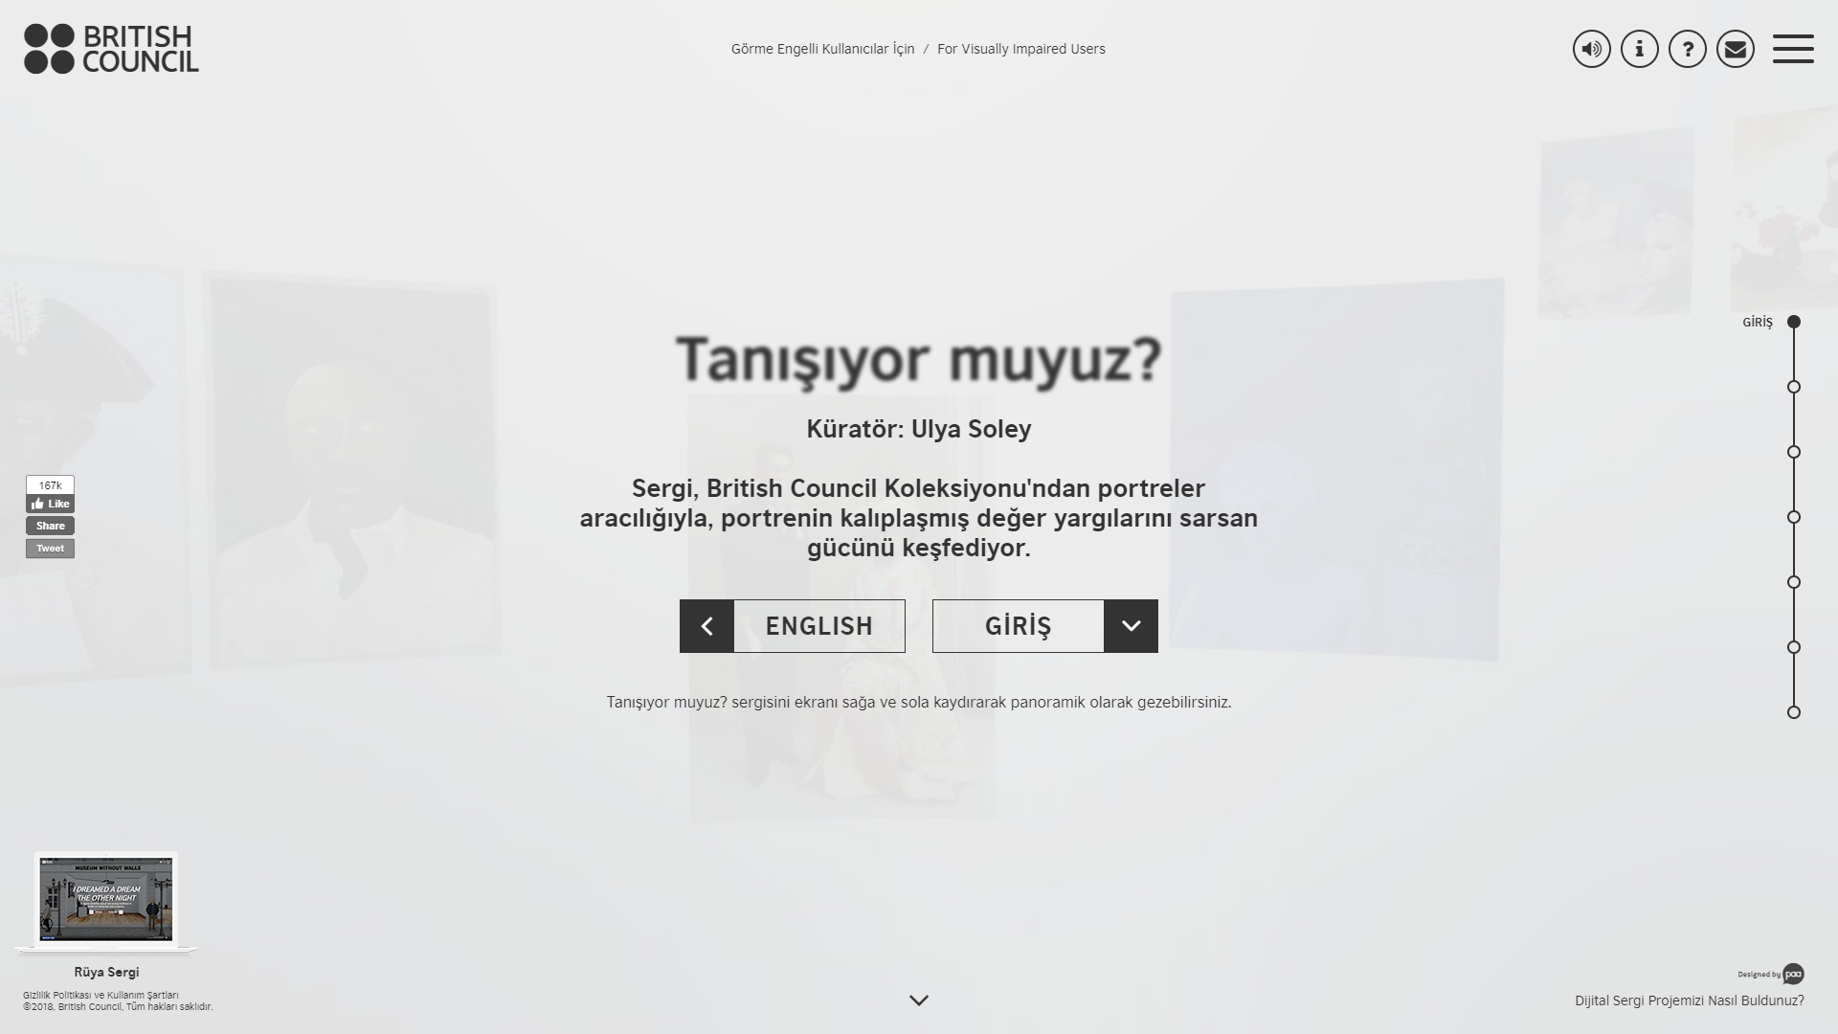

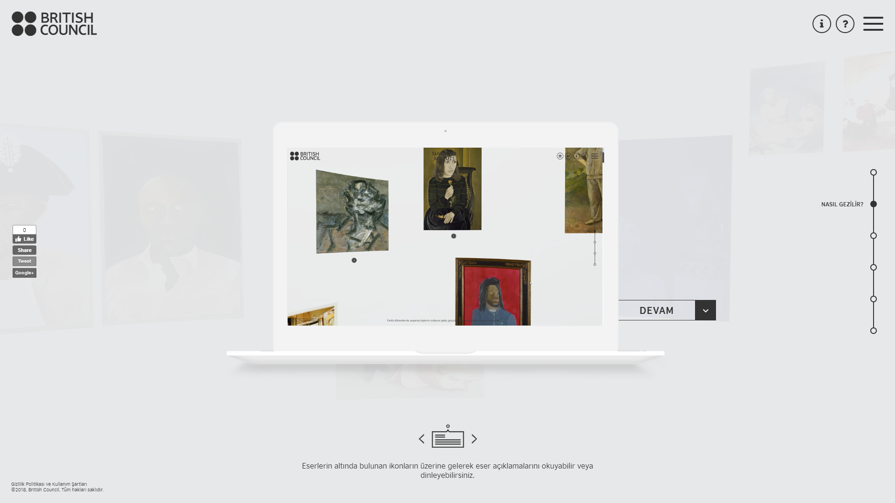

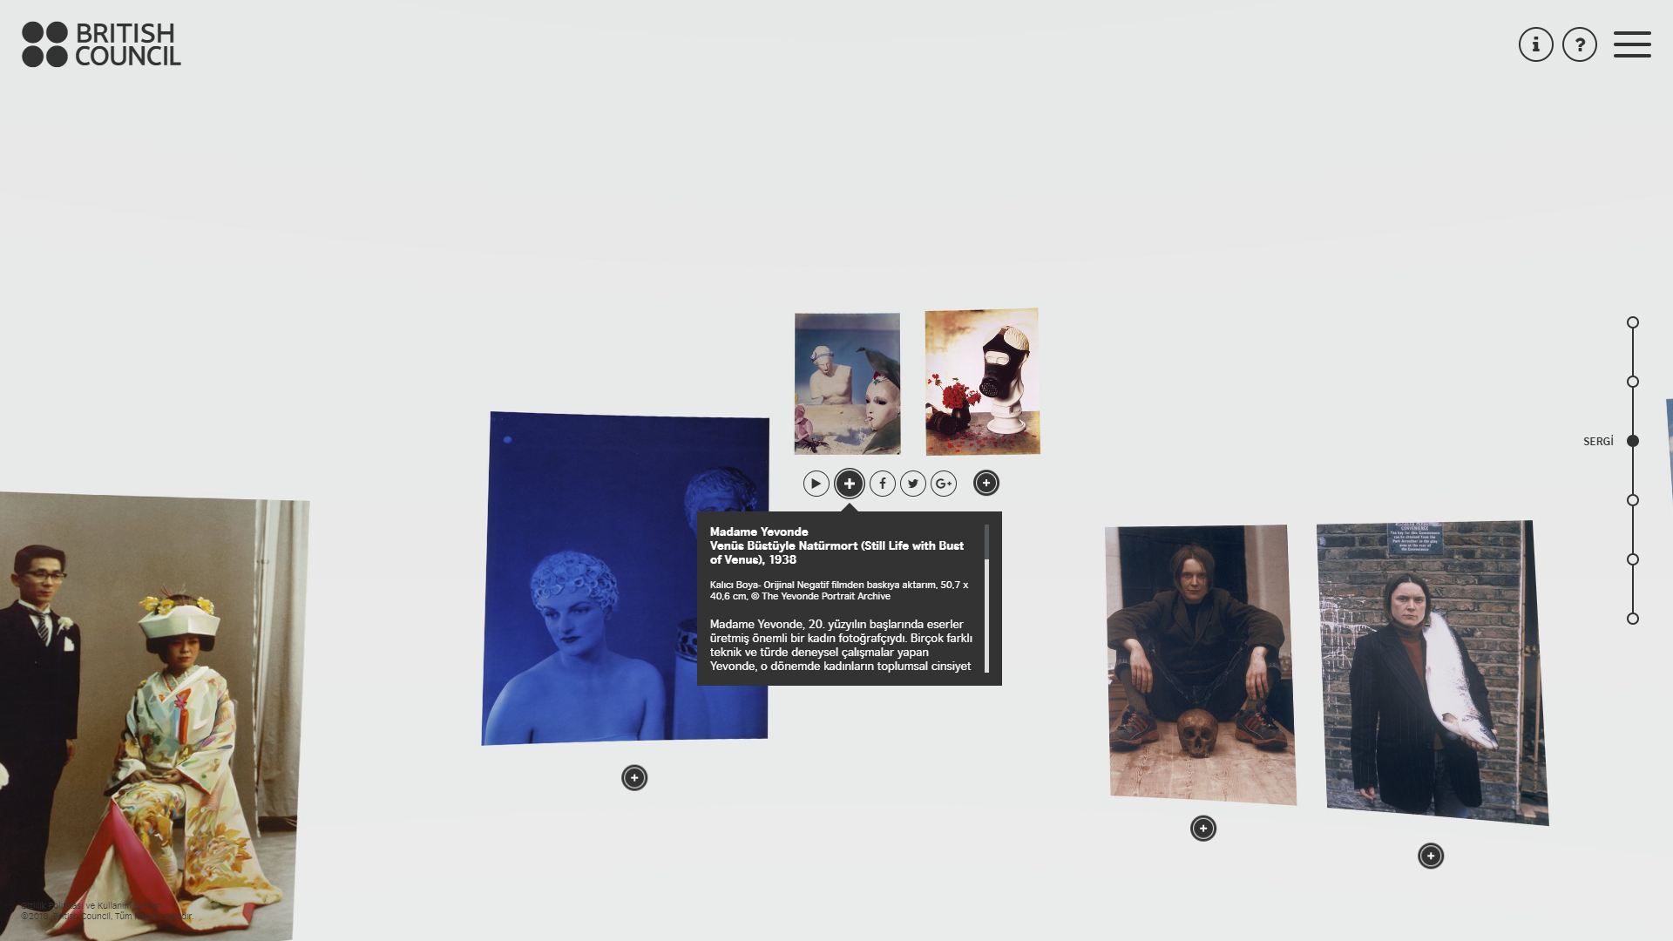

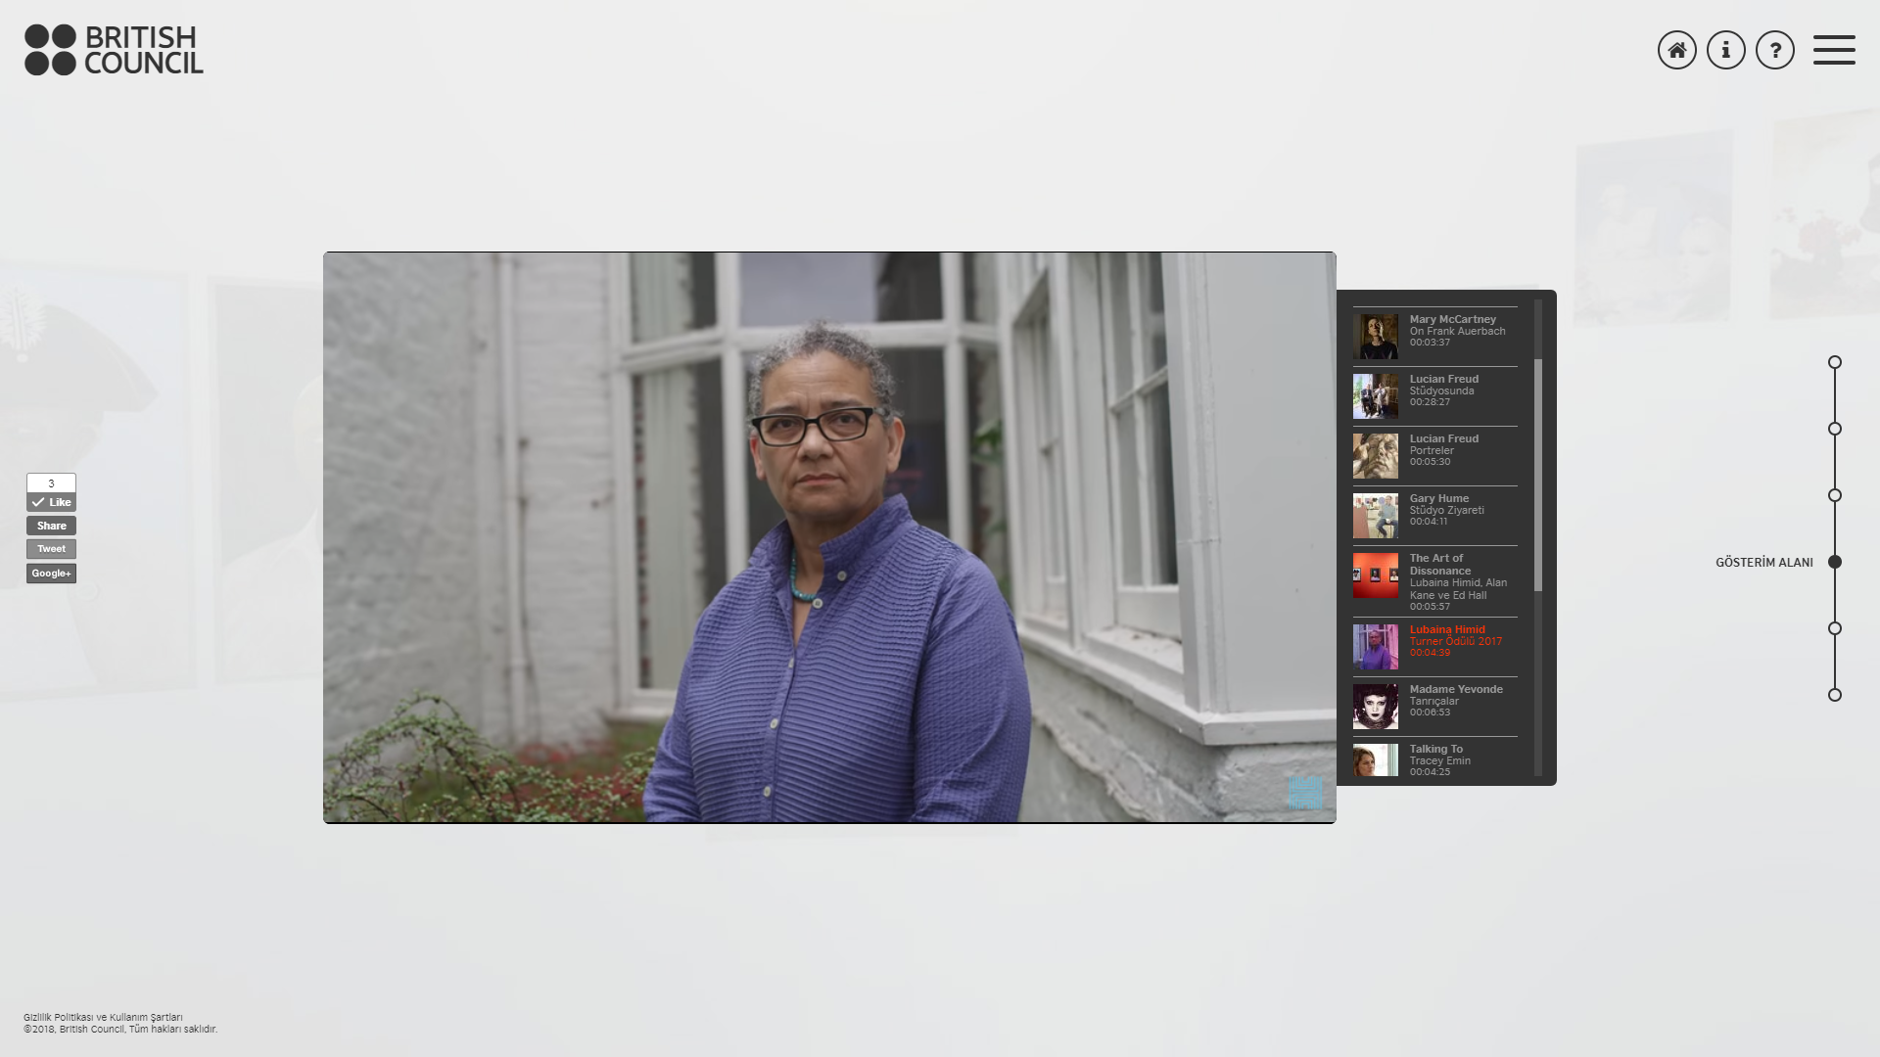

### Photos from the launch event

<https://www.flickr.com/photos/britishcouncilturkey/albums/72157692771983105>

### Interview with Curator

[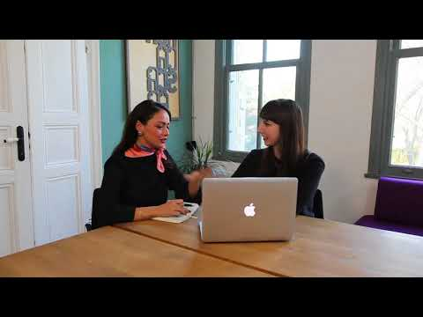](https://www.youtube.com/embed/HZKbMxOEW_c?feature=oembed)