Confidentiality and Use of Data
In line with EU GDPR law, all application data has been treated as confidential throughout the judging and shortlisting process by everyone involved.
Conflict of Interest
All applications are anonymised for the judging process and judges take conflict of interest very seriously to ensure the integrity of the process, including signing relevant agreements. If judges recognise an applicant, they are required to state any conflict of interest immediately. Any judge disclosing a conflict of interest is excluded from assessing the specific application and scores are provided by other members of the judging panel only.

Ahmet Acar
Associate Professor, ODTU and CEO & Founder HistoCan
Alumni of Cancer Research UK Manchester Institute
Study UK Alumni Awards, Science and Sustainability Award, 2024
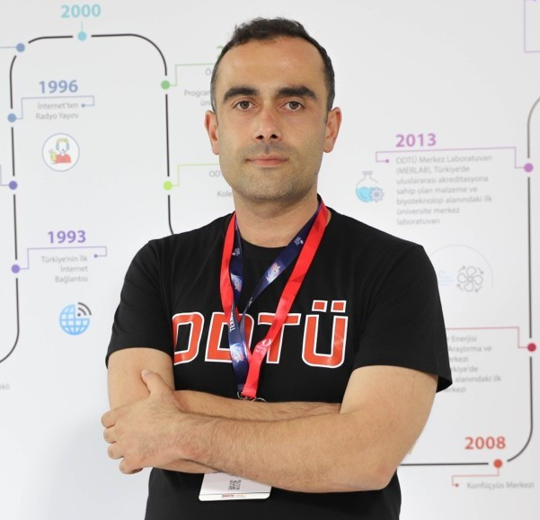
Dr. Ahmet Acar completed his undergraduate studies at Middle East Technical University (METU). He then enrolled in a PhD programme and received his PhD degree in 2012 from Cancer Research UK Manchester Institute. Next, Dr. Acar worked as a postdoctoral training fellow on cellular and cancer biology fields at the University of Manchester and the Institute of Cancer Research in London, respectively. As of the beginning of 2020, Dr. Acar returned Turkey to establish his own research group at METU with the support of TÜBİTAK International Fellowship for Outstanding Researchers Program. Dr. Acar’s lab focuses on understanding the underlying mechanisms of drug resistance using evolutionary principles. Dr. Acar is the founder and CEO of a startup company, HistoCan, based at METU Teknopark.

Denise Waddingham
Country Director at the British Council in Türkiye
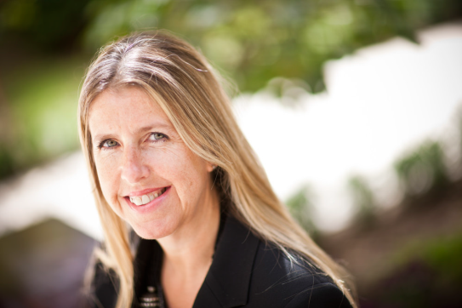
Denise has worked for the British Council for the past 25 years, joining as an English teacher in Slovakia in 1999 before posts in Myanmar, Nigeria, Kuwait, Egypt, Tunisia, the Czech Republic and Uzbekistan. She was previously Assistant Director in Nigeria and Kuwait, Director Partnerships in Egypt, Deputy Director in Tunisia and Country Director Czech Republic, before taking up her current post as Country Director Uzbekistan and Central Asia Cluster Lead in October 2021. She has experience across the breadth of the British Council’s work.
Denise is from Sussex and graduated from Brunel University in London with a BA (Hons) in English Literature and American Studies and also has a Postgraduate diploma in Teaching English as a Foreign Language (DELTA).

Bahar Taşkın Öztürk
Founder of INAN and CGO at Twiser
Study UK Alumni Awards, Business and Innovation Award Winner, 2025
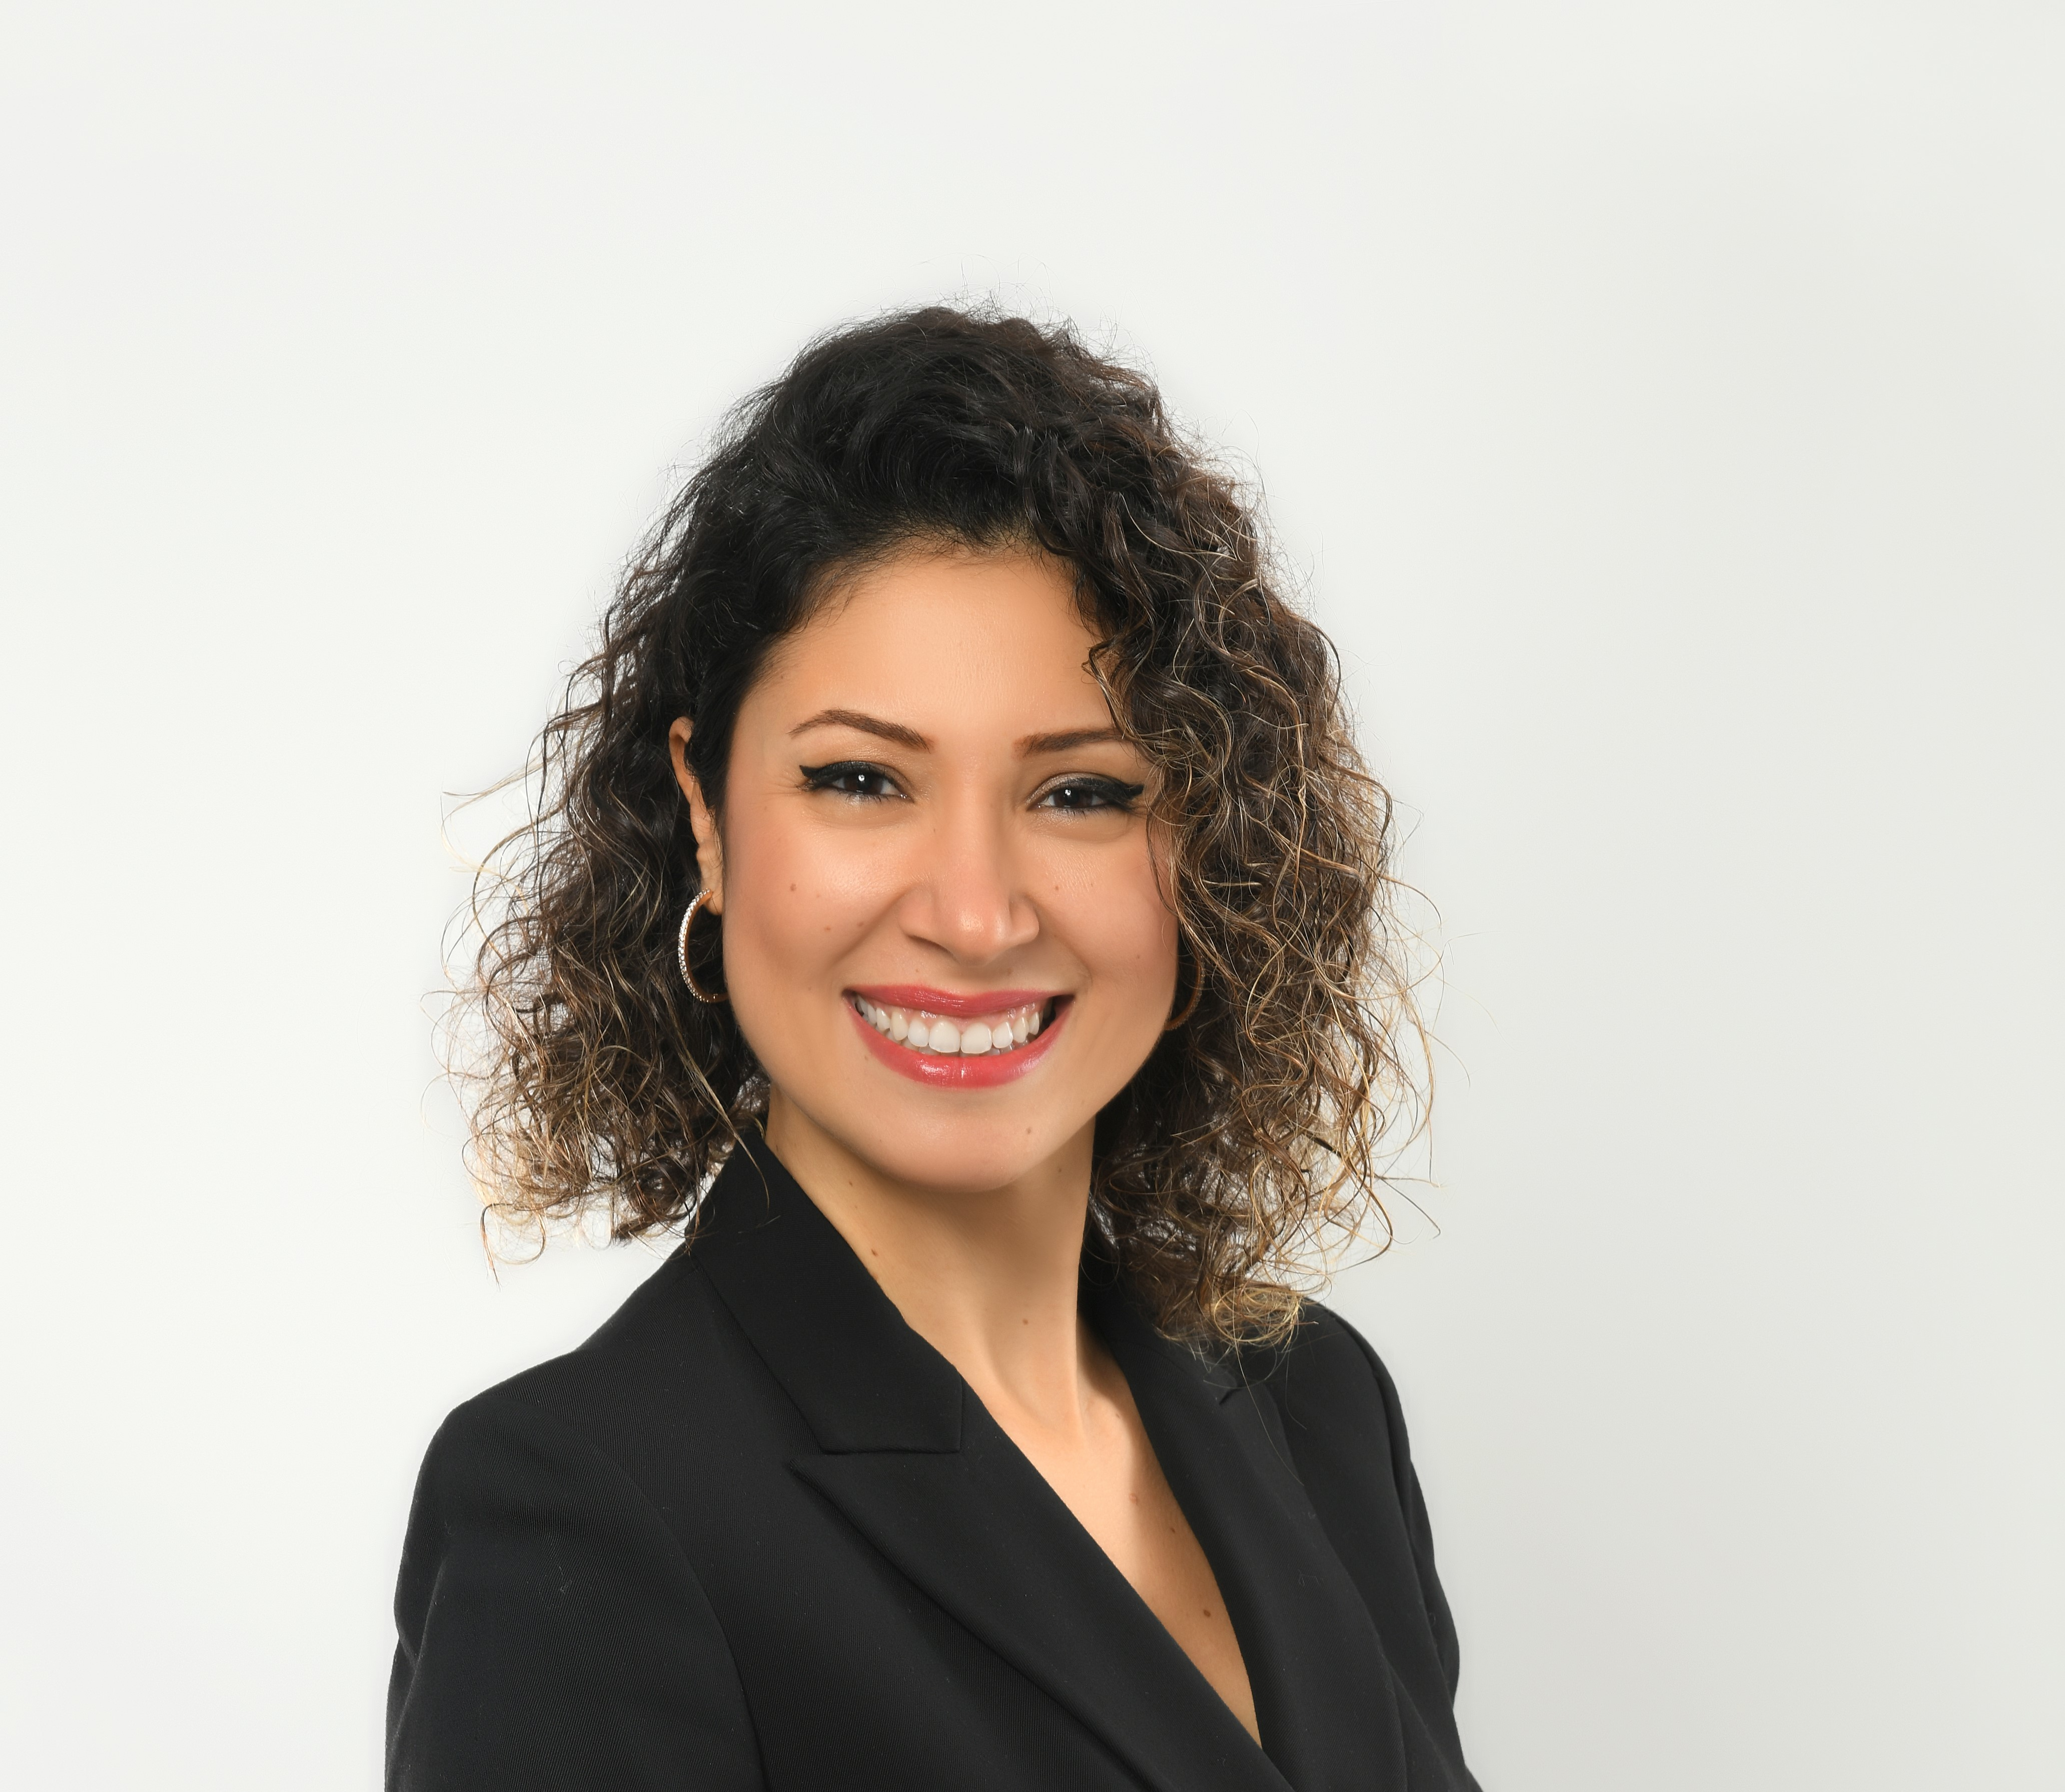
Bahar Taşkın Öztürk is a visionary leader dedicated to fostering diversity and inclusion within corporate success. She champions sustainable change through personal development and transformative corporate dynamics. As the founder of INAN and CGO at Twiser, she leads initiatives that benefit civil society and organisations.
Bahar has held significant roles, including Country Manager for the MENA region at Tupperware and Sales and Marketing Director for Turkey. She earned an Executive MBA from Koç University and holds a bachelor’s degree in economics and management from the University of London, having studied through its International Programme in collaboration with Bilgi University. Through this programme, she took courses from the London School of Economics (LSE), gaining a globally recognised education that shaped her strategic thinking and leadership approach.
Recognised by InStyle magazine as one of the 40 Pioneering Women prioritising social benefit, she collaborates with Harvard Business Review to host prominent figures, further amplifying her impact in corporate and social transformation.
Elif Berektli
Journalist at TRT World
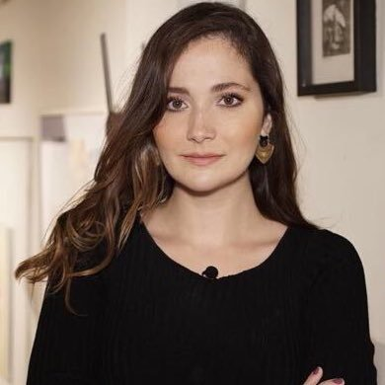
Study UK Alumni Awards, Culture and Creativity Award Winner, 2025
Elif Bereketli is a Germany-born, Turkish bilingual journalist with nearly two decades of experience in media.
Passionate about exploring the intersections of creativity, society, and politics, she has taken on
multiple roles—including presenter, executive producer, editor-in-chief, writer, and translator—contributing to TV, magazines, documentaries, podcasts, and newspapers.
Currently a presenter at TRT World, Elif is known for her critical approach to broadcasting and long-form storytelling, uncovering cultural narratives from around the world.
She is the founder and former editor-in-chief of SabitFikir, a contemporary literature magazine dedicated to making cultural criticism accessible and empowering those who feel excluded from artistic conversations.
Beyond journalism, she has hosted international events on topics such as humanitarian issues, technology, culture, and tourism, collaborating with organizations including the United Nations, Web Summit, and the British Council.
She holds a master’s degree in Cultural Studies from SOAS, University of London, where she developed a postcolonial perspective that continues to shape her storytelling. Her work has earned her numerous accolades, including being named one of the "10 Most Inspiring Women in Arts and Culture" by Vogue Turkey and featured on Elle Turkey’s list of the "20 Most Powerful Turkish Women Under 30."

