Museum Without Walls

Does it feel cosy?

Curators: Rita Aktay – Ritika Biswas

2021

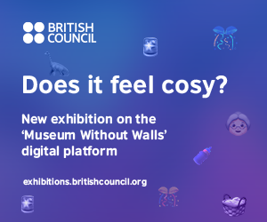

I had such a strange dream last night... We were all hanging laundry in the garden, and a massive dinosaur was just chilling there, bottle-feeding my grandma some milk in its lap!? Then these sirens went off and it started raining confetti – the whole thing turned into a giant garden-party with ALL our friends.

### Artists

Sharon Aivaliotis, Shirley Baker, Ursula Biemann, Elif Biradlı, Flo Brooks, Chila Kumari Burman, Helen Chadwick, Jayashree Chakravarty, Tacita Dean, Rohini Devasher, Suki Dhanda, Ayçesu Duran, Anna Fox, Lubaina Himid, Siobhan Hapaska, Jun Hasegawa, Sibel Horada, Shirazeh Houshiary, Delaine Le Bas, Clare Leighton, Goshka Macuga, Paula Rego, See Red Women's Workshop, Charlotte Schmitz, Eda Sütunç, Madame Yevonde, Zadie Xa

### Curator

Rita Aktay, Ritika Biswas

### Curatorial text

Exploring what it means to feel at home within and outside of oneself, Does It Feel Cosy? looks at the female body, domestic space and planetary ecologies as sites of anxiety, rumination, and kinship. In holding space for joy and grief to co-exist, this oneiric journey meanders across the emotional and political landscapes of care and crisis, survival and belonging.

By playing with what feminist, socially-engaged, or ecological art might mean, the exhibited works eventually render such categories porous. Women speak to glaciers, household objects become alien, racialised bodies break their silence, and monsters become intimate. Through humour, exaggeration, modification, beautification, and intervention, the works activate curiosity and solidarity, creating infinite portals between lived and imagined worlds.

Bringing together works from the British Council Collection as well as the works of international contemporary artists, we share visions of community, collective survival, and cross-species nurture, especially as the global pandemic continues to unfold its fundamental, unsettling effects.

In assembling this digital exhibition, we considered what it means to curate with care by enabling multiple journeys for each viewer. By clicking on single or multiple emojis, you not only reveal charged and weird interrelations of solidarity across the works, but also filter the intensity of your engagement with these narrative worlds.

### Artwork list (in alphabetical order)

* Sharon Aivaliotis, *Love Is Your Last Chance*, 1984, Mezzotint 75cm x 56,5cm, From the British Council Collection.
* Shirley Baker, *Ice Cream Van on A Terraced Street, Manchester 1965*, 1965 - *Five Young Children on A Manchester Pavement, Hulme 1965*, 1965, Two colour photographs, 34cm x 51cm, © The Artist. From the British Council Collection.
* Ursula Biemann, *Subatlantic*, 2015, Video excerpt, 07’26’’, © The Artist.
* Elif Biradlı, *The Chosen Stone*, 2013, *What Is a Baby*?, 2016, *Funny Hunt*, 2016, *It's Not My Baby*, 2015, Four photographs in various format and sizes. Courtesy of the artist
* Flo Brooks, *U TURN*, 2018, *On My Way*, 2018, Acrylic on Wood, 110cm x 110cm x 3cm and Acrylic on Wood, 85cm x 800cm x 3cm © The Artist. Courtesy of the Artist and the Project Native Informant London. From the British Council Collection
* Chila Kumari Burman, *Punjabi Rockers*, 2005, Super high gloss work embellished with rhinestones, 118,9cm x 84,1cm © The Artist. From the British Council Collection.
* Helen Chadwick, *Meat Abstract #3*, 1989, *Meat Abstract #8*, 1989, Two colour polaroid prints, 50,8cm x 61cm ©The Estate of Helen Chadwick. Courtesy of Estate of Helen Chadwick, Richard Saltoun Gallery. From the British Council Collection.
* Jayashree Chakravarty, *Earth As Heaven*, 2018, Video documentation of installation work, 03’39’’, © Jayashree Chakravarty. From the Akar Prakar / Kiran Nadar Museum of Art, New Delhi Collection. Video courtesy: Akar Prakar
* Tacita Dean, *Ariel View of Teignmouth Electron, Cayman Brac 16th Of September 1998,* 2000, Photograph, 21cm x 26cm © The Artist. Courtesy the artist and Frith Street Gallery, London. From the British Council Collection.
* Rohini Devasher, *Bloom*, Video, 06’09’’ © The Artist.
* Suki Dhanda, *Untitled,* 2002, *Untitled*, 2002, C-Type prints mounted on aluminium, 125cm x 125cm © The Artist. From the British Council Collection.
* Ayçesu Duran, *Monolith of The Estranged*, 2020, Ironing board, natural stone veneer, reading light, 152cm x 65cm x 38cm © The Artist.
* Anna Fox, *Untitled (From the series Friendly Fire; Weekend Wargames In Britain 1989-1994)*, 1992, C-Type colour print, 50,8cm x 61cm © The Artist. From the British Council Collection.
* Lubaina Himid, *Dream Team*, 2014, *Have Courage in the Crisis Set Yourself Free*, 2016, Acrylic on canvas, 48cm x 67cm and Acrylic on paper © The Artist. Courtesy the Artist and Hollybush Gardens. From the British Council Collection.
* Siobhan Hapaska, *Untitled*, 1997, Screenprint, 57,8cm x 89cm, © The Artist. From the British Council Collection.
* Jun Hasegawa, *Body #2*, 2000, Household gloss on canvas, 304cm x 183cm © The Artist. From the British Council Collection.
* Sibel Horada, *Migration Wave*, 2019, Video documentation of installation work, 03’53’’, © The Artist.
* Shirazeh Houshiary, *Gravity*, 2004, Black aquacryl, white pencil and ink on canvas, 190cm x 190cm © The Artist. From the British Council Collection.
* Delaine Le Bas, *What We Don’t Know, Won't Hurt Us (Self-Portrait),* 2006-2018, Mixed Media, 293cm x 54cm © The Artist. From the British Council Collection.
* Clare Leighton, *Washing Clothes, Corsica,* 1934, Wood engraving, 21,6cm x 25,6cm © Courtesy of the Estate of Clare Leighton. From the British Council Collection.
* Goshka Macuga, *Make Tofu Not War*, 2018, Woven tapestry, 293cm x 447cm, © The Artist. Courtesy of the Artist and Kate McGarry London. From the British Council Collection.
* Paula Rego, *Ring-A-Ring O'Roses*, 1989, Etching with aquatint, 52cm x 38cm, © The Artist. From the British Council Collection.
* See Red Women's Workshop, *Girls Are Powerful*, 1983, *So As Long As Women Are Not Free The People Are Not Free*, 1975, Screenprint, 79cm x 54cm and Poster, 64cm × 45cm © See Red Women’s Workshop.
* Charlotte Schmitz*, I Am So Beautiful, So Beautiful (four photographs from the series)*, 2013 – ongoing. Four photographs in various sizes. © The Artist.
* Eda Sütunç, *Baklava*, 2020, Kinetic sculpture (Resin, baklava, chrome suspension pipe and spring, DC motor, Raspberry Pi, cable), 190cm x 175cm x 100cm (Photography: Zeynep Fırat). Courtesy of the Artist and SANATORIUM
* Madame Yevonde, *Mrs Edward Meyer as Medusa*, 1935, *Crisis*, 1939, Two permanent dye-transfer prints from original negative, 50,7cm x 40,6cm ©The Yevonde Portrait Archive and the National Portrait Gallery. From the British Council Collection.
* Zadie Xa, *Call Waiting*, 2018, Machine stitched and hand sewn fabric, bleach and oil on canvas, 165cm x 193cm, Courtesy of the Artist and Galeria Augustina Ferreyra, Mexico City © Zadie Xa. From the British Council Collection.

### Project Team

Project Manager: Su Başbuğu, Arts Manager, British Council

Project Board: Esra A. Aysun, Head of Arts, British Council Turkey, Claire de Braekeleer, Regional Arts Director, British Council, Emma Dexter, Director Visual Arts, British Council, Cherry Gough, Country Director, British Council Turkey, Meltem Günyüzlü Ateş, Head of Marketing, British Council Turkey, Zoe Partington, Accessibility Advisor, Shakia Steward, Digital, Partnerships and Innovation, British Council

Artistic Advisor: Elliott Burns

Accessibility Advisor: Zoe Partington

Project Team: Zeynep Aybar, Arts Assistant, British Council Turkey, Nicola Heald, Collection Manager, British Council, Moira Lindsay, Head of Collection, British Council

Accessibility Editors: Sarah Pickthall, Jon Pratty

Audio Description: David Parker, Figment Arts and Accessible Everything

Sign Language Interpretations: Sue MacLaine (British), Dilmaç (Turkish)

Design & Development: IGOAIMALATHANE

### Screenshots from exhibition website

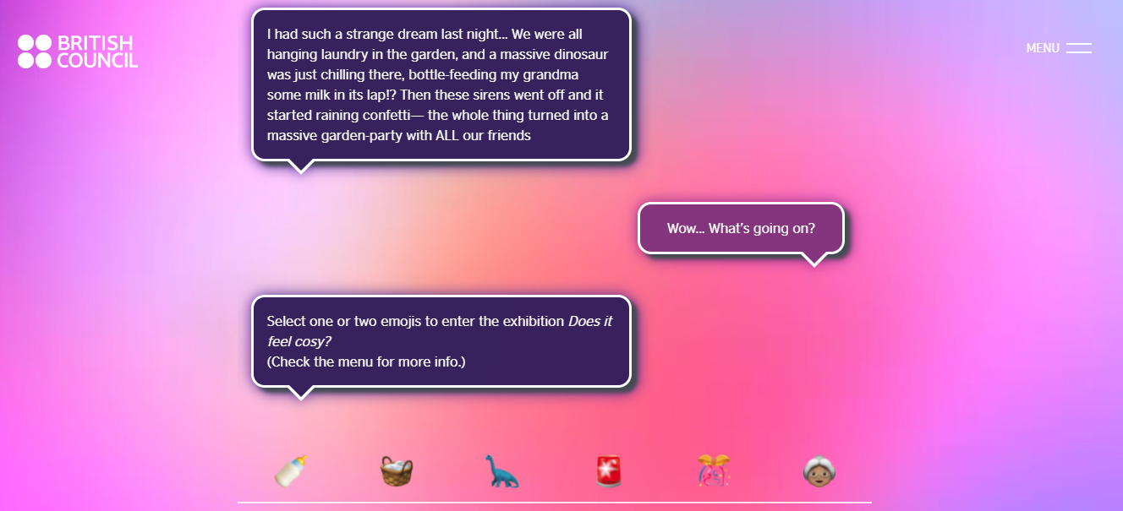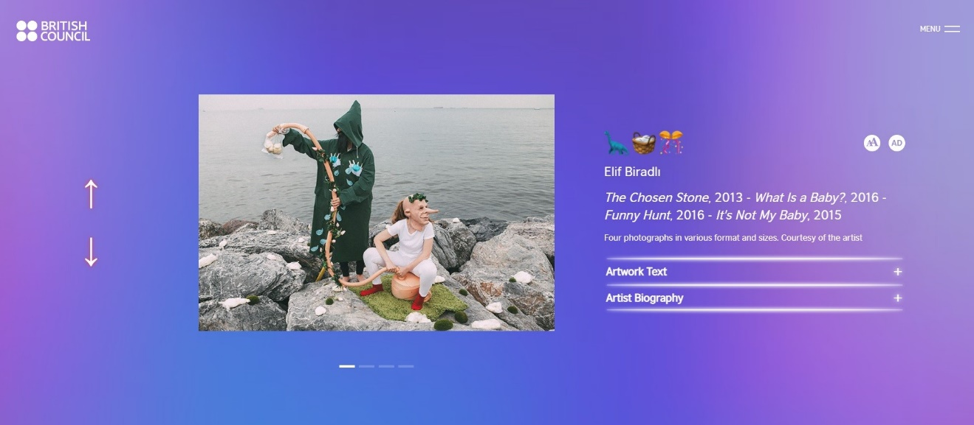

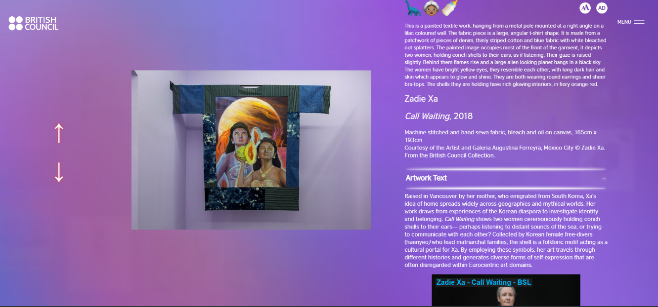

### Screen recording from exhibition

[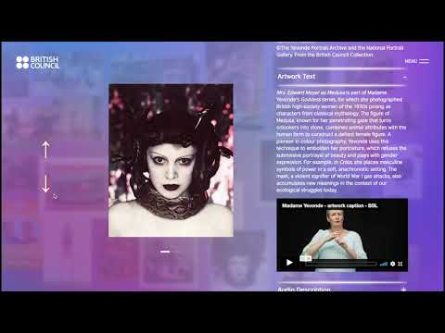](https://www.youtube.com/embed/LNAeUhAHJgQ?feature=oembed)

### Recording of launch event

[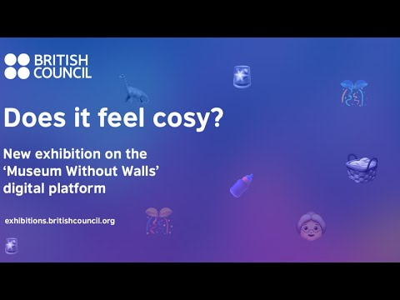](https://www.youtube.com/embed/Zf1TkZZQ80Y?feature=oembed)