Museum Without Walls

Dancing With Witches

Curator: Mine Kaplangı

2019

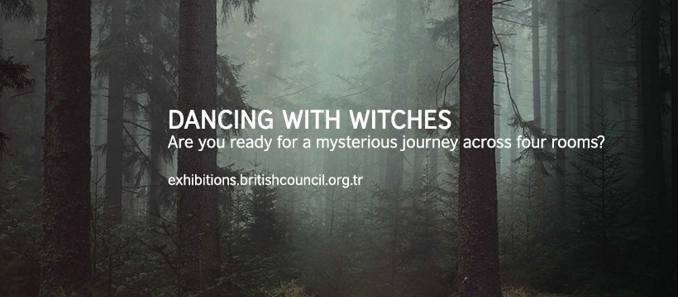

### Artists

Roger Ackling, Robert Sargent Austin, Sir Peter Blake, William Blake, Gerald Leslie Brockhurst, Fatma Bucak, Canan, Istanbul Queer Art Collective, Alan Davie, Anya Gallaccio, Nilbar Güreş, Aubrey Hammond, Gözde İlkin, Michael Landy, David Nash, Grayson Perry, Paula Rego, Erinç Seymen, Madame Yevonde, Lynette Yiadom-Boakye, Pınar Yolaçan

### Curator

Mine Kaplangı

### Curatorial text

To revisit an art collection established in the 1930’s through the notion and history of witchcraft presents us with the opportunity to observe certain details that have somehow been overlooked until now, whether this be deliberate or otherwise. The exhibition takes inspiration from a current focus on the witch/woman as a symbol of power and in particular from works of English literature which foreground women’s rights and equality. The viewers are invited to a journey, through a selection of art works from the British Council Collection, that underpins the role of female artists whose presence and influence within the history Western art has been concealed or swept aside, with the addition of works by contemporary artists from Turkey. Dancing with Witches will be the third edition of the digital arts platform, Museum without Walls, showcasing more than 20 works selected from different eras in addition to works from outside the collection for the first time this year, aiming to create a cross-continental dialogue. The exhibition will include works by Fatma Bucak, Canan, Nilbar Güreş, Gözde İlkin, Istanbul Queer Art Collective, Erinç Seymen and Pınar Yolaçan as well as the 1795 work, The Night of Enitharmon's Joy (formerly called 'Hecate') by one of the most celebrated English artists and poets of all time, William Blake.

It is possible to trace the marks left not only within the history of the West but almost in all mythology and cultures congruently, by an understanding of the notion of witchcraft and the witch as a particular figure. ‘The often defines the witch figure as any person who uses magic, or as the practitioner or a particular kind of nature based Pagan religion, or a symbol of independent female authority and resistance to male domination.’ (Ronald Hutton, The Witch, 2017). It is because of this that this symbolism is frequently taken up in literature, the arts and particularly in story telling as a figure of empowerment for women. The figure who, in various mythologies, fairy tales, myths or frightening stories appears as the antagonist, sometimes doing deals with the devil, flying on a broom, casting spells over a bubbling cauldron, dancing around campfire, today embodies the potential to transform into a symbol that can foreground a new wave of feminism, highlighting the urgency with which history, ever repeating itself, needs re-examined. Rituals, symbols, familiars, signs, alternative means of acquiring knowledge, female sexuality, the woods or the use of particular plants ... What is then at the heart of the fear that has been instilled for centuries by way of this representation?

The reason behind the anonymity of women in history and art history is the conventional patriarchal recording of history. Neither the literary world, a great influence on many thinkers and writers, nor the art world truly took it upon themselves, to record or chronicle the missing names of the rare appearances these apparitions are able to make now and then.

The exhibition thus questioning the British Council Collection in this very sense, takes its lead from works, authors and examples of feminist writing in English Literature. Consequently writers such as Virginia Woolf, Emily Brontë, William Blake, Elizabeth Gaskell and William Butler Yeats have been included to be a part of this journey. For these writers the consideration of the position of women in society, the female body, the means of knowledge distribution and alternative means of producing knowledge initiated by women was a main subject matter as well as a lifelong concern. How can we explain what moved these writers and thinkers so, and why they placed the position of women in society, the struggle for equal rights and most significantly the female body into the centre of their literary works and through these influenced generations of women to come and planted the very seeds of the notions and ideas that led to the entirety of feminist movements. These very seeds then, must be found within all that has been overlooked within the history of the arts.

The figure of the witch used as a political statement in art by Blake and others alike, brings to mind the history of the witch hunts and trials between the 14th-18th centuries in Europe and its periphery, a warfare that took thousands of lives of mostly women, between the Catholic church and its laws on one side and paganism and nature on the other. We are able to trace the clues to this history through the representations used in the works of these artists. From the weird sisters in Macbeth to Virginia Woolf’s A Room of One’s Own, now more than ever it has become essential to be able to reconstitute and understand the history of the witch and her craft, considering that witch hunts in our time continue incessantly in all their violence.

The figure of woman as witch in its terrifying physical and mental image is the inspiration behind numerous daring art works, stories and myths, and is one of many recurring figures in many works within the British Council Collection. These works are in dialogue with one another through their means of expression, and their potential to reveal the significance of reconsidering the history of witchcraft through art. What if we were to perceive the history of witchcraft not through the perspective of men, but that of feminist art, literature and in particular through the context of female sexuality and allow these witches to become sources of power? Dancing With Witches invites you to a rereading of representations, symbols, rituals that continue to exist; the power of nature and the diversity it manifests, in search of spells, as a means of finding answers together to the questions posed here. Though the witch in this rereading is taken as a source of power, nevertheless, throughout history and irrespective of borders and regions, she remains a being whose underlying potential has been feared, whose powers have been hidden and obscured and whose voice has been silenced, dancing in harmony with nature. And whoever and whatever else there may be in the history of art that has been denied representation must be remembered through similar journeys, and be represented and written into history.

At a time where witches, vampires, fairies and other such magical beings exist, words and images should not be the only means of transmitting stories. Perhaps we must all dance as witches, together with witches.

*This exhibition was dedicated to Anna Goldi who is said to be the last of the many thousands of people between the 15th-18th centuries executed for practicing witchcraft. She was executed in Glarus in 1782.

### Artwork list

The exhibition was divided into four different rooms and was comprised of works from the British Council Collection and international artists.

**Myths and Stories**

‘Women have served all these centuries as looking glasses possessing the magic and delicious power of reflecting the figure of man at twice its natural size.’

Virginia Woolf, A Room of One's Own

This part is dedicated to all of the stories, novels, and fairy tales that make you wonder what is behind the door, and the rhymes that you can hear from a distance if you listen carefully when walking in the woods at night.

* Sir Peter Blake, But It Isn’t Odd Tweedledum Cried, 1970, Screenprint, 66 x 51 cm © Peter Blake. All rights reserved, DACS 2019. From the British Council Collection.
* Sir Peter Blake, So Alice Picked Him Up, 1970, Screenprint, 66 x 51 cm, © Peter Blake. All rights reserved, DACS 2019. From the British Council Collection.
* William Blake, The Night of Enitharmon's Joy (formerly called 'Hecate'), Composition Date: 1795, Print Date: c. 1795-96 / This is the only extant impression of ‘Hecate’ from the c. 1795-96 printing session. Planographic colour printing with water colour and pen and ink additions to the impression, 43.9 x 58.1 cm, ©Courtesy of Tate Collection
* Fatma Bucak, And then God blessed them, 2013, Video, 9’26’’ ©Courtesy of artist and Pi Artworks
* CANAN, Dream, Dream, Dream, 2014, Miniature, ink and gold on special paper, 48 x 33 cm ©Courtesy of the artist and Esra Sarıgedik Private Collection
* CANAN, Night, 2014, Photography, gold and ink on special paper, 35 x 60 cm © Courtesy of the artist
* Paula Rego, There Was an Old Woman Who Lived in a Shoe, 1989, Etching with Aquatint, 52 x 38 cm © Courtesy of the artist. From the British Council Collection.
* Paula Rego, Little Miss Muffet, 1989, Etching with Aquatint, 52 x 38 cm © Courtesy of the artist. From the British Council Collection.
* Paula Rego, Baa, Baa, Black Sheep, 1989, Etching with Aquatint, 52 x 38 cm © Courtesy of the artist. From the British Council Collection.
* Paula Rego, Lady Bird, Lady Bird, 1989, Etching with Aquatint, 52 x 38 cm ©Courtesy of the artist. From the British Council Collection.

**Rituals and Symbols**

Magic circles, witch’s marks on trees, mirrors, dancing around the fire and many more… This section is dedicated to the importance of repetition and the power of rituals as a recall when it comes to the ones that are near/almost forgotten.

* Roger Ackling, The Wedding at Cana, 1980, Sunlight on wood, 61 x 45 x 4 cm ©Annely Juda Fine Art, London. From the British Council Collection.
* Fatma Bucak, I was not able to prevent the fall, 2013,HD video, 42 sec ©Courtesy of the artists and Pi Artworks
* Alan Davie, Untitled(1), 1988, Lithograph, 42,5 x 34,5 cm © The Artist, Courtesy of the Estate of the artist and Gimpel Fils. From the British Council Collection.
* Alan Davie, Untitled(2), 1988, Lithograph, 42,5 x 34,5 cm © The Artist, Courtesy of the Estate of the artist and Gimpel Fils. From the British Council Collection.
* Alan Davie , Untitled(3), 1988, Lithograph, 42,5 x 34,5 cm © The Artist, Courtesy of the Estate of the artist and Gimpel Fils. From the British Council Collection.
* Nilbar Güreş, Head Standing Totem, 2014, C-print, 100 x 150 cm ©Courtesy of the artist and Galerie Martin Janda, Vienna
* Nilbar Güreş, No mask is needed, a hairy woman is scary enough for you, 2014 2 pieces collage, textile colour on black fabric, 75,5 x 100,5 cm, 70 x 100 cm ©Courtesy of the artist and Galerie Martin Janda, Vienna
* Nilbar Güreş, No mask is needed, a hairy woman is scary enough for you, 2014, 2 pieces collage, textile colour on black fabric, 75,5 x 100,5 cm, 70 x 100 cm ©Courtesy of the artist and Galerie Martin Janda, Vienna
* Aubrey Hammond, The Old Women, 1921, Theatre Poster, 79 x 54 cm. From the British Council Collection.
* İstanbul Queer Art Collective, Fluxus Remakes Vol I: Sweeping Walk -channel video installation, All performed by Tuna Erdem © Courtesy of Istanbul Queer Art Collective
* Sweeping Walk: Phaselis, Polis, Performans video 20'24'', 2014, Orijinal score by Nam June Paik, Dragging Suite, 1963
* Sweeping Walk: Gezi, Performans video 17'29'', 2014, Original score by Milan Knizak, Sunday Event, 1965
* Sweeping Walk: Istiklal, Performans video 20'59'', 2012, Original score by Milan Knizak, Sunday Event, 1965
* Sweeping Walk: Phaselis, Necropolis, Performans video 14'41'', 2014, Original score by Nam June Paik, Dragging Suite, 1963
* Erinç Seymen, Sorcerer’s Wife, 2016, 5 pieces, serigraphy on paper, 74 x 53.5 x 4 cm (each) ©Courtesy of the artist and Zilberman Gallery

**Familiars and Nature**

What happens when we listen to the sound of the woods, dive into the woods and work together with nature? This section is dedicated to the night keepers of all jungles, forests, and woods.

*Named as familiar spirits in some sources and seen as nature's guides, familiars is a name given to the supernatural entities believed to help and guide witches and usually taking the forms of different animals (the most commonly known is the black cat) or even plants.

* Anya Gallaccio, Forest Floor, 1995, Black and White Photograph, 15 x 30,5 cm ©Anya Gallaccio. All Rights Reserved, DACS 2019. From the British Council Collection.
* Gözde İlkin, Reverie of Space, 2017, Mixed media on fabric with poem, 120 x 148 cm © Courtesy of the artist
* Michael Landy, Smooth Hawks’ Beard, 2002, Etching, 89 x 75 cm ©Courtesy of the artist and Thomas Dane Gallery. From the British Council Collection.
* Michael Landy, Creeping Buttercup, 2002, Etching, 89 x 75 cm ©Courtesy of the artist and Thomas Dane Gallery. From the British Council Collection.
* Michael Landy, Herb Robert, 2002, Etching, 89 x 75 cm ©Courtesy of the artist and Thomas Dane Gallery. From the British Council Collection.
* Michael Landy, Herb Robert, 2002, Etching, 89 x 75 cm ©Courtesy of the artist and Thomas Dane Gallery. From the British Council Collection.
* David Nash, Ash Dome – Bent, Pruned and Mulched, 1985, Mixed Media Drawing and Black and White Photography, 57 x 39,5 cm ©David Nash. All rights reserved, DACS 2019. From the British Council Collection.
* David Nash, Fletched – Over Ash Dome, 1982, Mixed Media Drawing, 80,5 x 122 cm ©David Nash. All rights reserved, DACS 2019. From the British Council Collection.
* Madame Yevonde, Toadstool, 1934, Permaprint Dye-Transfer Print from Original Neg, 50,7 x 40,6 cm ©The Yevonde Portrait Archive. From the British Council Collection.

**Portraits**

This section showcases different portraits of women from different periods of time carrying many spells and secrets, boiling pots for different knots.

* Gerald Leslie Brockhurst, The West of Ireland, 1928, Etching, 14,5 x 12,2 cm ©Richard Woodward. From the British Council Collection.
* Grayson Perry, Untitled, 2015, Woodcut with lithographic underlay, 72,5 x 48,5 cm ©The Artist, Courtesy of the artist and Victoria Miro. From the British Council Collection.
* Grayson Perry, Untitled, 2015, Woodcut with lithographic underlay, 72,5 x 48,5 cm ©The Artist, Courtesy of the artist and Victoria Miro. From the British Council Collection.
* Madame Yevonde, Self Portrait with Image of Hecate, 1940, Permaprint Dye-Transfer Print from Original Neg, 50,7 x 40,6 cm ©The Yevonde Portrait Archive. From the British Council Collection.
* Madame Yevonde, Mrs Edward Meyer as Medusa, 1935, Permaprint Dye-Transfer Print from Original Neg, 50,7 x 40,6 cm © The Yevonde Portrait Archive. From the British Council Collection.
* Lynette Yiadom-Boakye, Study for Anaconda, 2005,Charcoal and conte on paper, 58 x 41,5 cm ©Lynette Yiadom-Boakye. Courtesy of the artist Jack Shainman Gallery, New York and Corvi-Mora, London. From the British Council Collection.
* Lynette Yiadom-Boakye, Study of Two Heads, 2005, Charcoal and conte on paper, 59 x 42 cm ©Lynette Yiadom-Boakye. Courtesy of the artist Jack Shainman Gallery, New York and Corvi-Mora, London. From the British Council Collection.
* Pınar Yolaçan, Untitled (Jen), 2003, Photography, 81 x 100 cm ©Courtesy of the artist
* Pınar Yolaçan, Untitled (Magda), 2003, Photography, 81 x 100 cm ©Courtesy of the artist

### Awards

Horizon Interactive Awards:

* Gold Award in Entertainment Industry
* Best of Category in Mobile Responsiveness

Webby Awards

* Official Honoree – Website Art

Golden Spider Awards

* Third place: Best Event and Culture Website
* Best Microsite
* Best Mobile Website

### Project Team

Project Manager: Su Başbuğu, British Council

Project Advisers: Esra A. Aysun, British Council, Moira Lindsay, Head of British Council Collection, Ebru Yetişkin, Curator and Lecturer at Istanbul Technical University

Communications: Mirel Akdemir, Özlem Ergun, British Council

British Council Collections Nicola Heald

Audio Description :SEBEDER

Sign Language: Dilmaç

Web Design and Implementation IGOAIMALATHANE

Accessibility Advisor: Zeyra Technology

### Screenshots from exhibition website

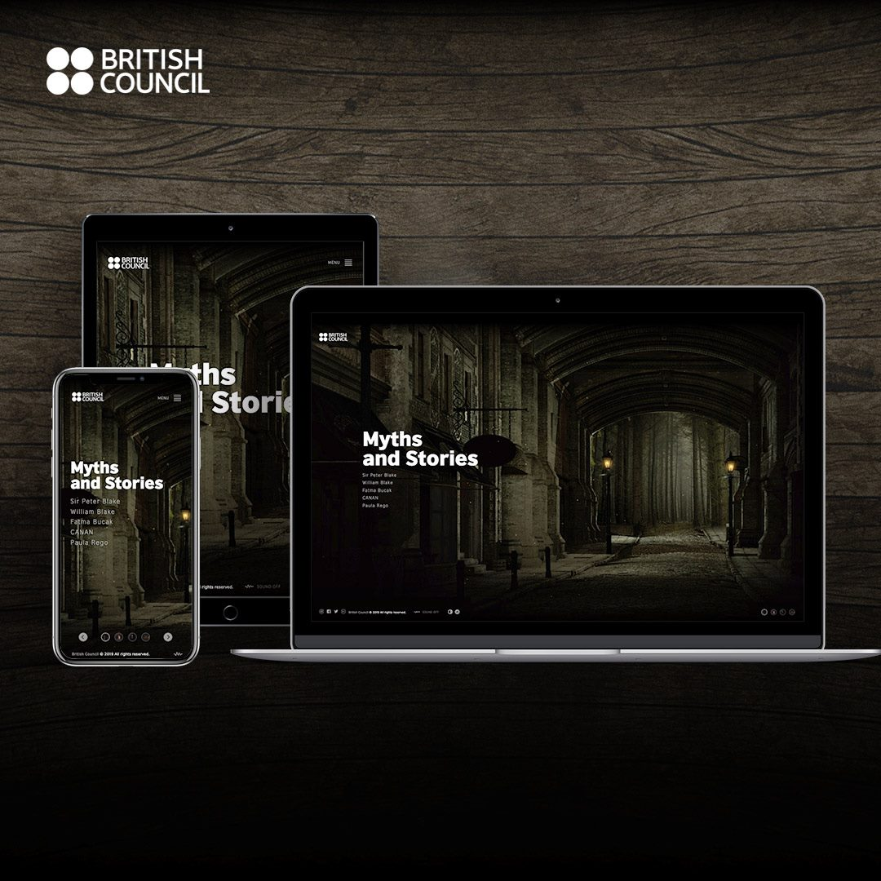

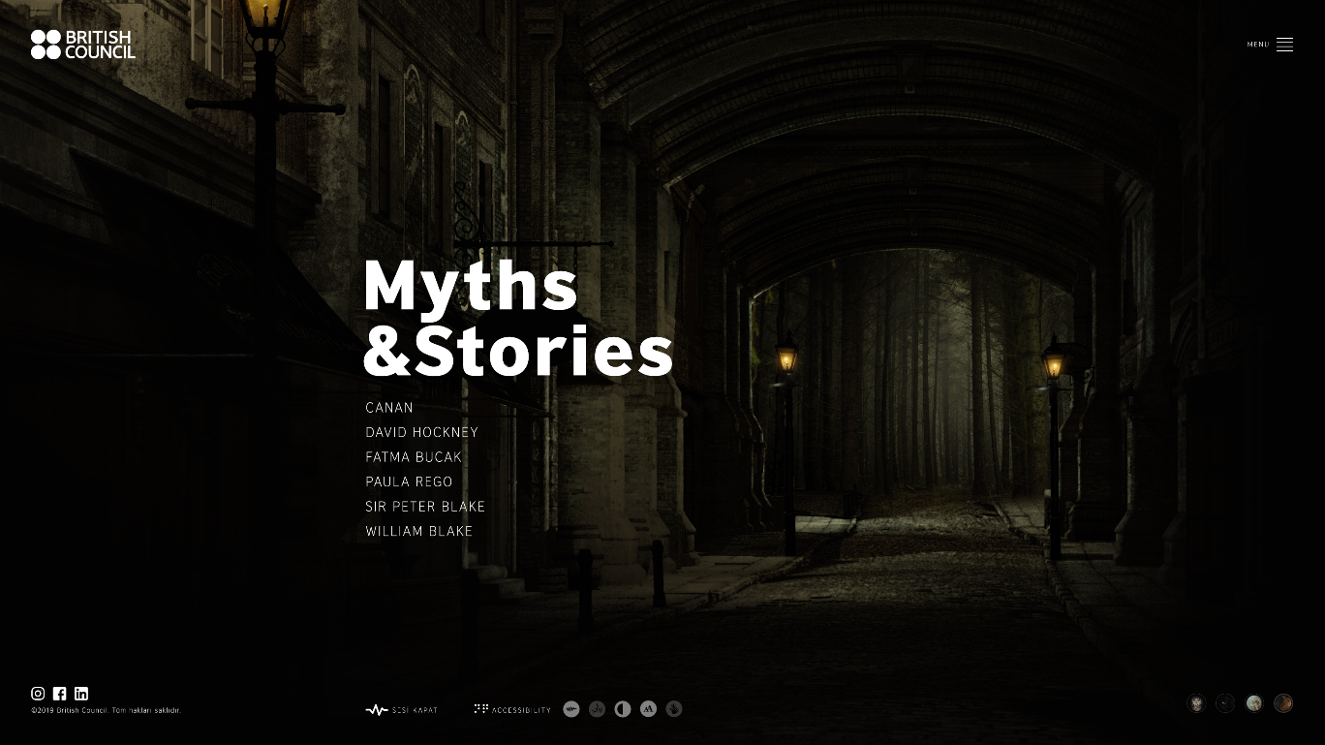

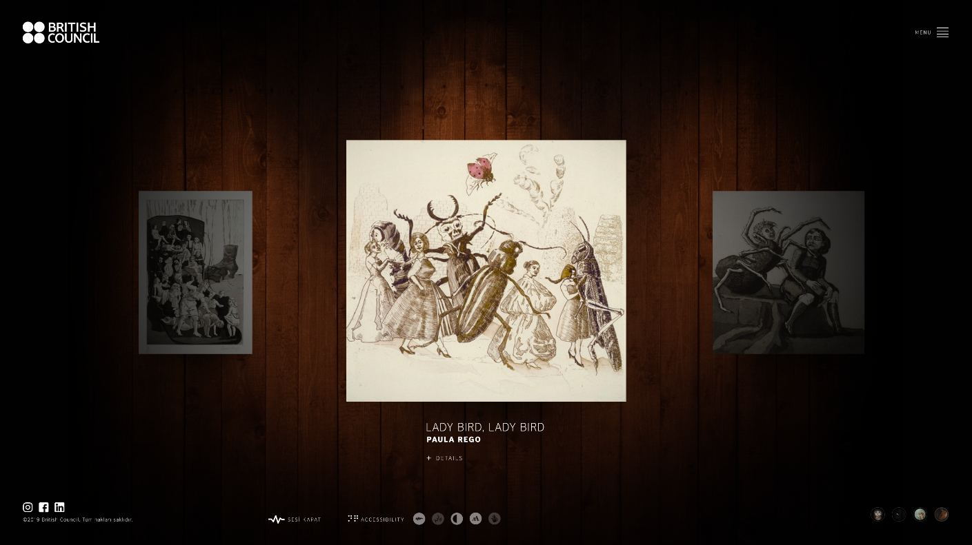

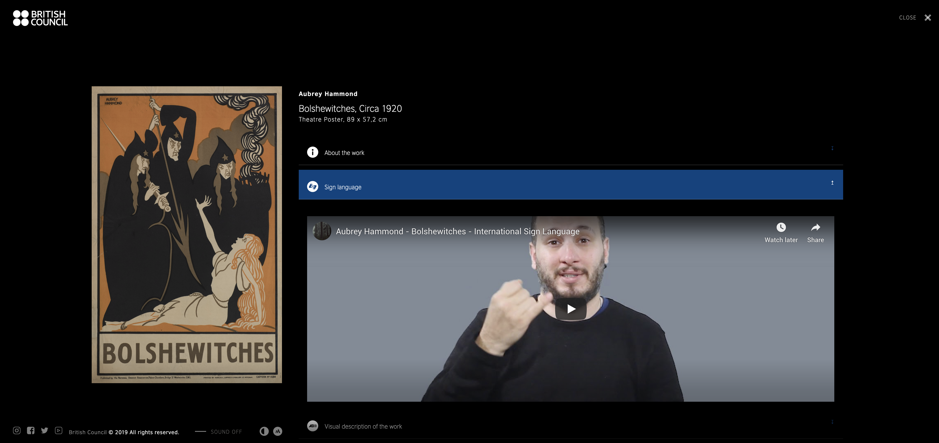

### Recording of launch event

[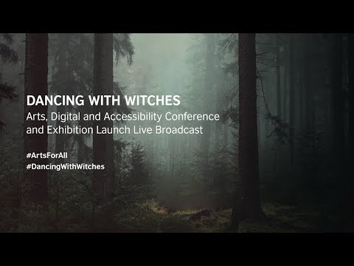](https://www.youtube.com/embed/8ed5TMN9L4s?start=1&feature=oembed)

### Photos from the launch event

<https://www.flickr.com/photos/britishcouncilturkey/albums/72157689009016623>