Museum Without Walls

Almost There

Curators: Teona Burkiashvili, Tatiana Kochubinska, Seyhan Musaoğlu

2020

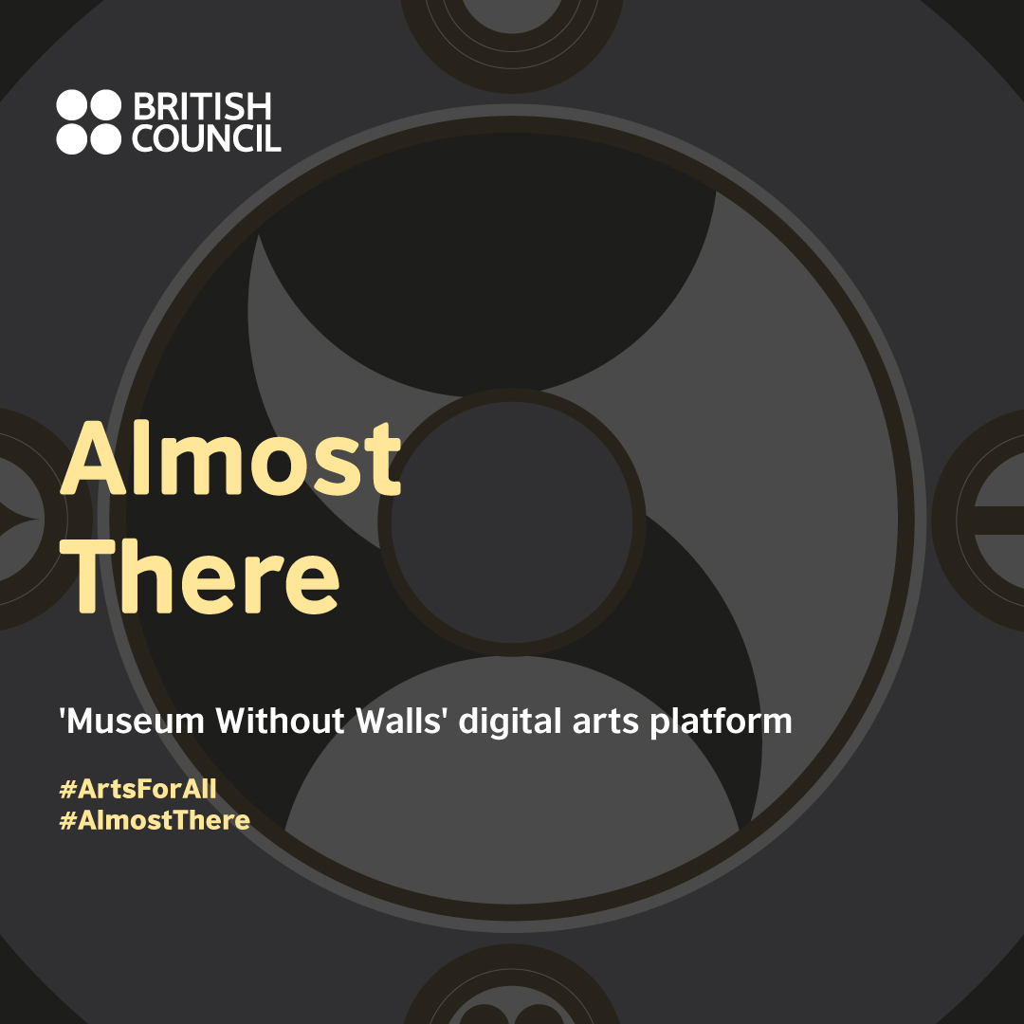

A digital exhibition with artworks from the British Council Collection as well as Georgia, Turkey and Ukraine, curated by Teona Burkiashvili, Tatiana Kochubinska, Seyhan Musaoğlu.

We invite you into a circular journey where while politics and emotions collide, our physical movements cross over with our consciousness.

### Artists

Öykü Aras, Terry Atkinson, Luna Ece Bal, İrakli Bugiani, Marc Chaimowicz, Bernard Cohen, Leman Sevda Darıcıoğlu, Suki Dhanda, Jimmie Durham, Tracey Emin, Yaroslav Futymskyi, Leyla Gediz&İnci Furni, Tamar Giorgadze, Oleg Holosiy, Uli Golub, Natela Grigalashvili, Richard Hamilton, Mona Hatoum, Rita Khachaturiani, Ansel Krut, Sasha Kurmaz, Valery Lamakh, Langlands&Bell, Richard Long, Gareth Mcconnell, Paul Nash, Maia Naveriani, Cornelia Parker, Ceren Saner, Dmytro Starusiev, John Stezaker, Ali Emir Tapan, Ayça Telgeren, Anna Zvyagintseva

### Curator

Teona Burkiashvili, Tatiana Kochubinska, Seyhan Musaoğlu

### Curatorial text

“..I don’t have much time, I hurry to my infinity and how can I know something if I cannot reach my infinity and I never know what will happen in the end...” Valery Lamakh, Books of Schemes, vol. 1, p. 252.

This exhibition meditates on human beings’ eternal wish to define a place of one’s own in relation to a country, or in relation to one’s internal aspirations for the self. Offering an insight to the contemporary human condition by reflecting on degrees of separation and displacement, the exhibition shows artworks which explore social constraints as well as visible and invisible borders. The idea of a universal identity is examined through a journey that the viewer is invited to take in this virtual exhibition.

Almost There questions states of being in circular movements (both physical and mental, political and ritualistic). It uses the notion of travel as a means to reflect on an emotional and physical transformation of the self against a background of changing political realities. Making use of ritualistic elements within artist works, the exhibition is structured through an account of a travel diary the viewer is invited to interact with on a digital platform.

It is constructed in a spherical manner, as seen in the piece by Langlands & Bell entitled WWW. The transparent quality in this work alludes to a state of visibility, but also being enclosed in a square crystal glass box illustrates the constraints that are also created. Being present on the world wide web, out in the open, but also enclosed within, unable to reach out are all current states that every individual can relate to. While taking the globe as a metaphor of one’s own world and surroundings, the participant is encouraged to trace the links in this search of belonging through the chosen artworks to illustrate this journalistic diary.

Almost There unfolds from the emblematic thinking of space expressed through the sign of Valery Lamakh Circle of Eternal Return, which is a central concept of his philosophical essay collection called Books of Schemes. His sign that he has devised, illustrates a specific assertion of the universe in its entirety. “I am not in the world, I am the world,‘’ he wrote in the 1960s, and it becomes referential to the opportunities and constraints in a global nomadic world today.

A constant self-awareness becomes an overarching thesis throughout the whole exhibition that unfolds in three chapters: Location, In Between and Dislocation, which we the curators, invite you to experience.

Location reflects upon personal points of departure in relation to a place. In Between is the place of flux, that connects to roads leading to other chapters, displaying the human body as a tool of performative acts through shifting landscapes. Dislocation analyses possibilities alluding to the need to escape, sometimes creating blurred illusions, or the clearing of obstacles, constraints and borders, which we either fear or urge us to propel. The exhibition aims to allow participants to explore the inner borders within ourselves as individuals, in an ever changing backdrop of political disintegration and trespassing of boundaries, both psychological and physical..

### Artwork list

**In Between**

*This Chapter* acts as a bridge between *location* and dislocation, the other two sections of this digital experience. The artwork here connects and disconnects. We see transformation within ourselves and our surroundings. Changing landscapes and daily rituals and the relationship between time and space are explored in spiritual and physical ways. The human body is used as material, with performative elements in often non-linear storylines.

* Valery Lamakh (1925-1978), Circle of Signs, 1969–1970, Silver, black and white gouache on paper, diameter 16 cm ©Artist’s estate
* Luna Ece Bal (1992 -), Where I come from, 2017, Sea salt, mirrors, rose, candles, mixed media, dimensions variable ©Artist
* Yaroslav Futymskyi (1987 -), Who are all these people who have seen the same landscape?, 2018, Performance, 360 video documentation, sound, looped ©Artist
* Leman Sevda Darıcıoğlu (1985 -), A Childhood Tale From The Dark, 2019, Photo-documentation of video performance, in collaboration with Berivan Işık. Photographed by Hamdi Atay ©Artist.
* Tracey Emin (1963 -), Outside Myself (Monument Valley), 1994, Colour photograph, 65cm x 81cm ©Tracey Emin. All rights reserved, DACS 2020. From the British Council Collection.
* Richard Long (1945 -), Reflections in the Little Pigeon River, Great Smokey Mountains Tennessee, 1970, Photograph with text, 129,4cm x 87,7cm ©Richard Long. All Rights Reserved, DACS 2020. From the British Council Collection.
* Anna Zvyagintseva (1986 -), Paths, 2013, 49 drawings, each 14.5 x 20.5 cm, ink on paper, overall size 110 x 160 cm and video 10’ 41’’ looped ©Artist. Photographed by Maksym Bilousov.
* Terry Atkinson (1939 -), Ancient Gaelic Ghost After Completing A Tour Of Duty Haunting The Border, Passing Through A Decontamination Shower Before Going Off Duty. Note The Easter Cactus (Left) And How Brightly The Candle Continues To Burn, 1985, Pastel on black paper, 120cm x 107.5cm ©Artist. From the British Council Collection.
* Marc Camille Chaimowicz (1947 -), Interval no.2, 1979, Photographs, gloss paint and glass (diptych), 32cm x 64cm ©Artist. From the British Council Collection.
* Ceren Saner (1991 -), Leaves of Wild Waters, 2015, Three prints from analog photography series, dimensions variable ©Artist.
* Ali Emir Tapan (1983 -), Almost Flower, 2016, Colour video and sound, 3'20'' loop ©Artist
* Leyla Gediz and İnci Furni (1974 -) (1976 -), Self-Help, 2011, Video, 8’50’’ ©Artists
* Oleg Holosiy (1965-1993), Bridge, 1992, Oil on canvas, 198 cm x 298 cm, From the collection of the Pinchuk Art Centre (Kyiv, Ukraine). Photographed by Maksym Bilousov.
* Langlands and Bell, (1955 -, 1959 -), WWW, 1999, Laser engraved crystal glass, 10cm x 10cm x 10cm ©Langlands & Bell. From the British Council Collection.

**Dislocation**

This chapter looks at artworks, which deal with the urge to escape. Artists in this section are grappling with themes of constraints and borders, whether clear or blurred. Here, works emphasise notions of separation, displacement, inner and outer space as well as familiar and re-imagined landscapes. The stories they collectively tell are intertwined together, reflecting the ways in which physical and spiritual experiences transform us. So the journey or cycle of this chapter can continue in an open-ended way.

* Ayça Telgeren (1975 -), First image: Hand of the Artist, 2011. Second image: Shark Guitar No.3, 2015, First image: 35cm x 35 cm, ink on acid-free paper. Second image: 120cm x 35cm x 5 cm. Guitar designed and made by Cem Köksal, linden tree body and hard maple neck, painted with archival ink by Ayça Telgeren.
* Öykü Aras (1992 -), Spirit Explorer, 2019, Video documentation of live performance, 2’40’’ edit of three hour performance over three different days ©Artist.
* Richard Hamilton (1922-2011), Portrait of the Artist by Francis Bacon, 1970/71, Screenprint over Collotype, 82cm x 69 cm, ©R. Hamilton. All Rights Reserved, DACS 2020. From the British Council Collection.
* Gareth McConnell (1972 -), Meditations No 5, 2005, C-Type Photograph ©Artist. From the British Council Collection.
* Rita Khachaturiani (1982 -), Aria Behind the Wall, 2015, Oil on canvas, 70cm x 120 cm, ©Artist.
* Tamar Giorgadze (1983 -), Bring me the Horizon, 2018, Acrylic on canvas, 100cm x 120cm. ©Artist
* Sasha Kurmaz (1986 -), Tools of Resistance, 2013-2014, C-print, dimensions varied, ©Artist.
* Jimmie Durham (1940 -), Our House, 2007, Dry point on copperplate, 29.7cm x 42 cm, ©Artist. From the British Council Collection.
* Maia Naveriani (1966 -), Bunnies and Man, 2008, Coloured pencil and mixed media on paper, 180cm x 149 cm, ©Artist.
* Cornelia Parker (1956 -), Meteorite Lands on Buckingham Palace, 1998, Maple Boxed Frame, Map of London, Revealing Burn Mark Left by the Meteorite in various locations, 54cm x 69cm, ©Artist and Frith Street Gallery, London, From the British Council Collection.
* Uli Golub (1990 -), Babushka in Space, 2017, HD video 1920:1080, 3D animation, colour, stereo sound, 23’47’’, ©Artist.

**Location**

This Chapter is section of the exhibition devoted, in part, to nature. The works connect back to ancient landscapes and the presence of human beings within them. They also map out a sense of belonging to a specific place. This section considers the idea of place as realised exploration of historical roots, environment, politics, identity and traditional storytelling. The works collected in Location allow us to think about choice, and our own bodies in the context of a place. They question the stability and instability of borders, both physical and psychological, against a background of ever-changing political landscapes.

* Richard Long (1945 -), England, 1968, Black and white photography with text, 83,8cm x 114,3cm ©Richard Long. All Rights Reserved, DACS 2020. From the British Council Collection.
* Bernard Cohen (1933 -), Untitled (Black), 1973, Gouache on paper, 57cm x 76cm ©Bernard Cohen, courtesy Flowers Gallery, London. From the British Council Collection.
* Dmytro Starusiev (1984 -), Three Sisters, 2018, Developing out paper negatives, iron and selenium toning, photo paper, 200cm x 300 cm, ©Artist.
* Paul Nash (1889-1946), Landscape of the Megaliths, 1934, Oil on canvas, 49.5cm x 73.2cm. From the British Council Collection.
* John Stezaker (1949 -), Double Shadow XXIV, 2015, Collage, 53cm x 41.5cm, ©Artist and courtesy of The Approach, London. From the British Council Collection.
* Ansel Krut (1959 -), Woman with Monkey, 1985, Oil on canvas, 176cm x 118cm ©Ansel Krut. All Rights Reserved, DACS 2020. From the British Council Collection.
* Suki Dhanda (1969 -), Untitled, C-type mounted on aluminium, 125cm x 125cm ©Artist. From the British Council Collection.
* Mona Hatoum (1952 -), Projection, 2006, Cotton and abaca, 101cm x 151,5cm ©Mona Hatoum. All Rights Reserved, DACS 2020. From the British Council Collection.
* Irakli Bugiani (1980 -), Untitled (Sovieticum), 2013, Oil on canvas, 110cm x 180cm, ©Artist.
* Natela Grigalashvili (1965 -), The Doukhobors' Land, 2015, Photography, 40cm x 60cm, ©Artist.

### Awards

Golden Spider Awards

* Best Event and Culture Website
* Best Microsite
* Best Mobile Website
* Best Website of the Year

### Project Team

Project Manager**:** Su Başbuğu, Arts Manager, British Council

Project Advisors**:** Esra A. Aysun, Head of Arts, British Council Turkey, Maya Darchia, Arts Manager British Council Georgia, Moira Lindsay, Head of Collection, British Council Collection, Nikola Pavlovich, Regional Marketing Coordinator, British Council, Ying Tan, Curator, Ilya Zabolotnyi, Arts Manager, British Council Ukraine

Accessibility Editors: Sarah Pickthall, Jon Pratty

Consultant for Blind Accessibility: Ilgın Aydınoğlu

Audio Description: David Parker, Figment Arts, SEBEDER (For video works in Turkish), Dostupne Kino (Ukrainian, Russian languages).

Sign Language: Lamara Japoshvili (Georgian), Sue MacLaine, Brian Duffy (English), Igor Bondarenko (Ukrainian), Dilmaç (Turkish), Igor Bondarenko (Russian)

Design & Development: IGOAIMALATHANE

### Screenshots from exhibition website

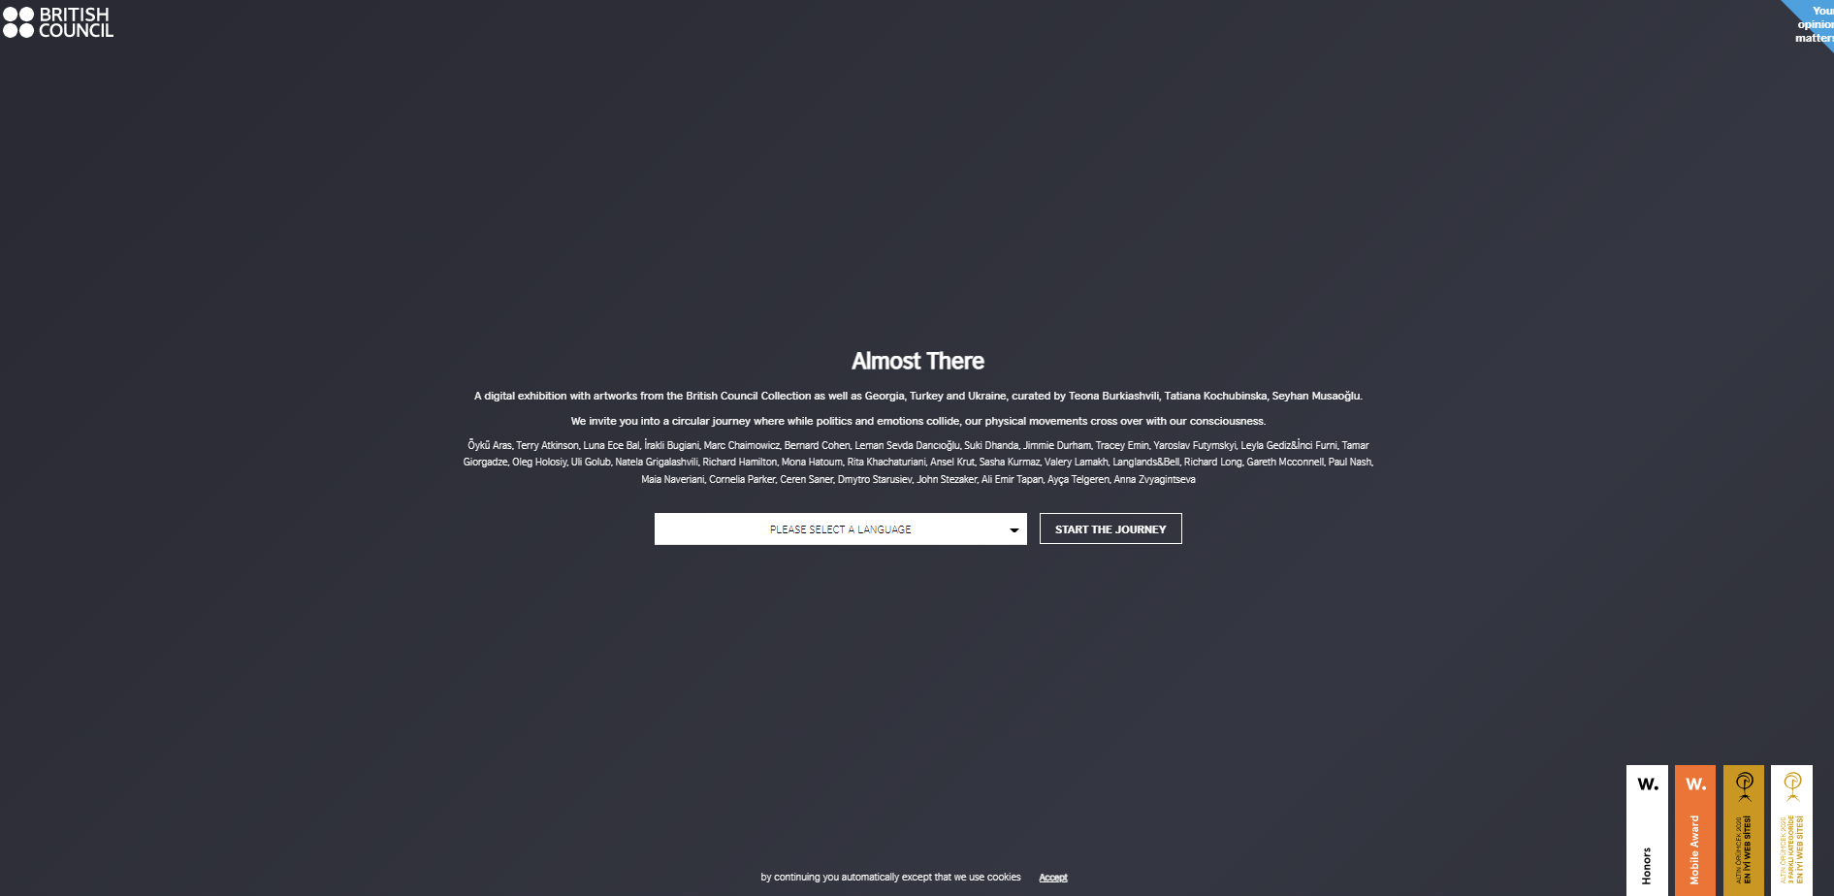

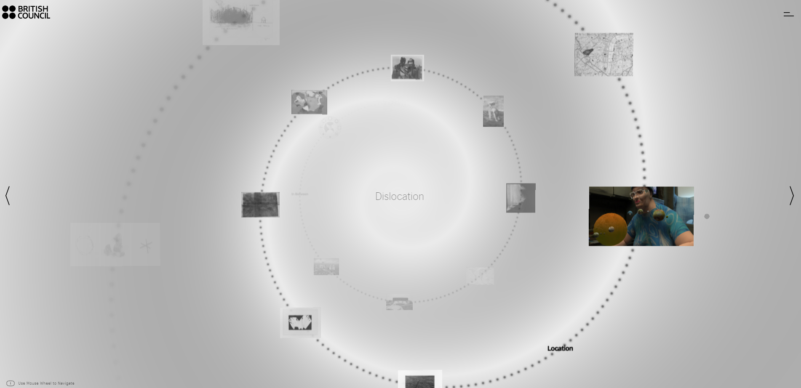

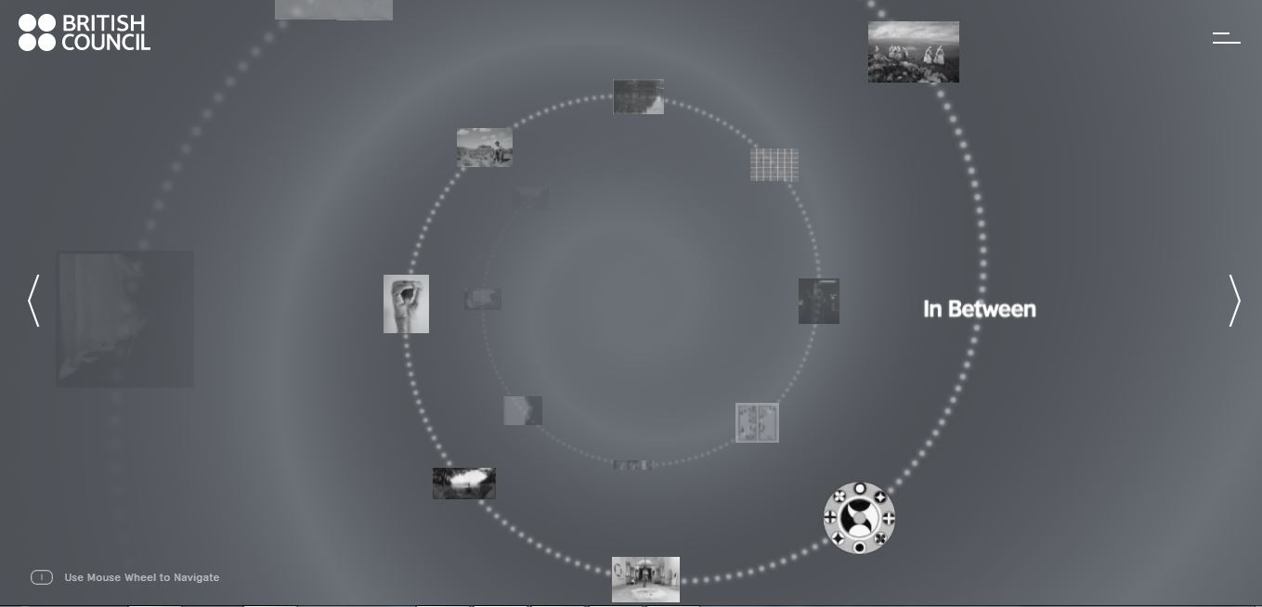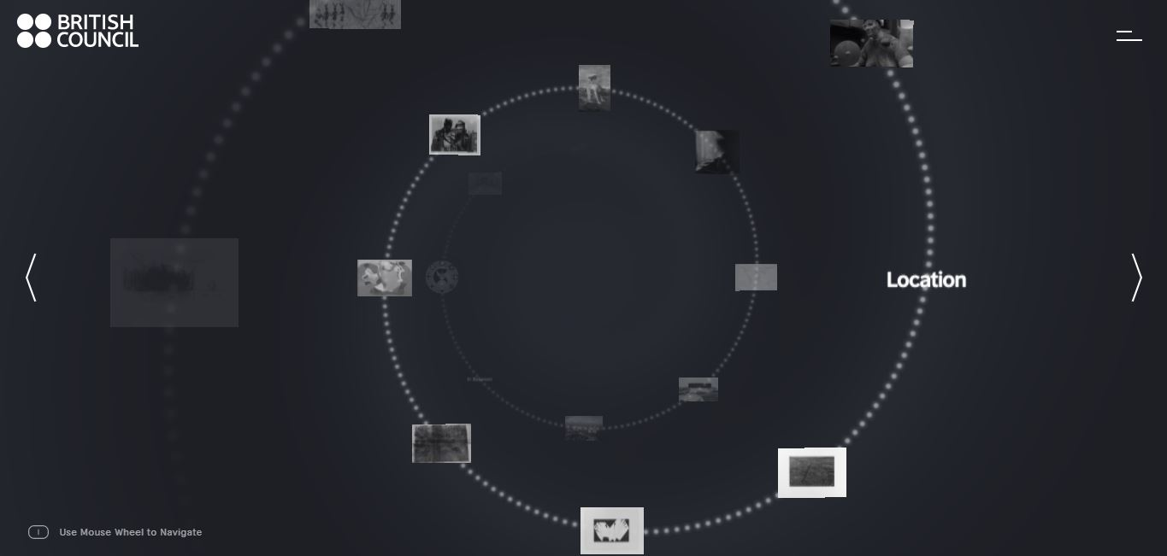

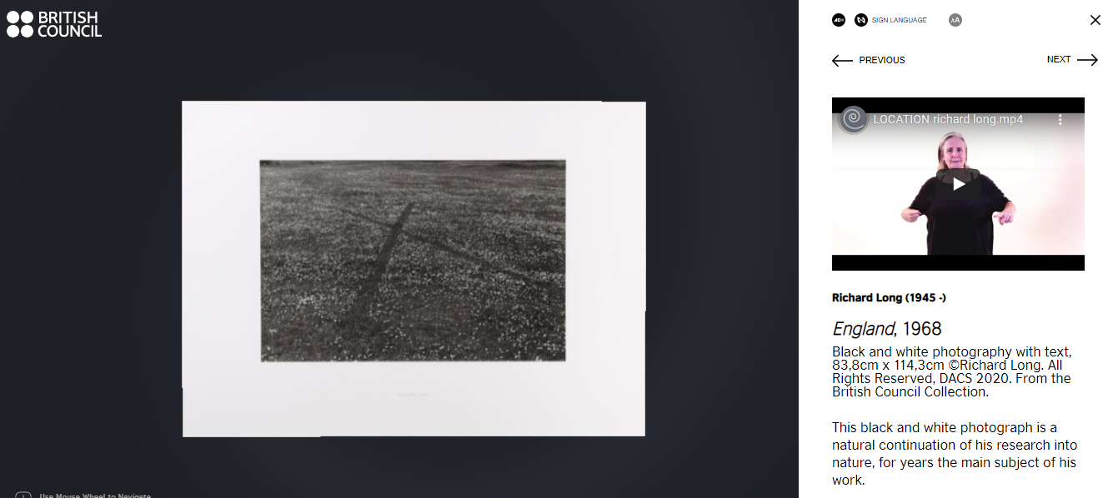

### Recording of launch event

[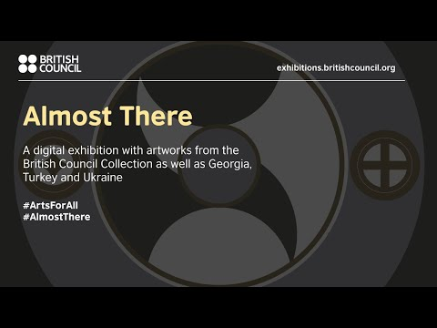](https://www.youtube.com/embed/8ksNeygQttA?feature=oembed)

### Photos from the launch event

<https://www.flickr.com/photos/britishcouncilturkey/albums/72157713078722521>